Student focus Student success
Victor Valley Community College District
- Annually, VVCC graduates approximately 1,000 students with an associate’s degree.
FACILITIES
Existing Infrastructure
- 40 principal buildings
- 710 rooms
- 377,209 gross square feet of building space
- 485,244 gross square feet of outside space

Future Developments
($297.5M general obligation bond)
- Public Safety Training Center:
Educational complex in partnership with Apple Valley Fire Protection District

- Workforce Development Job Training Center:
Includes a Business Academy and a Health Sciences Academy

STAFFING

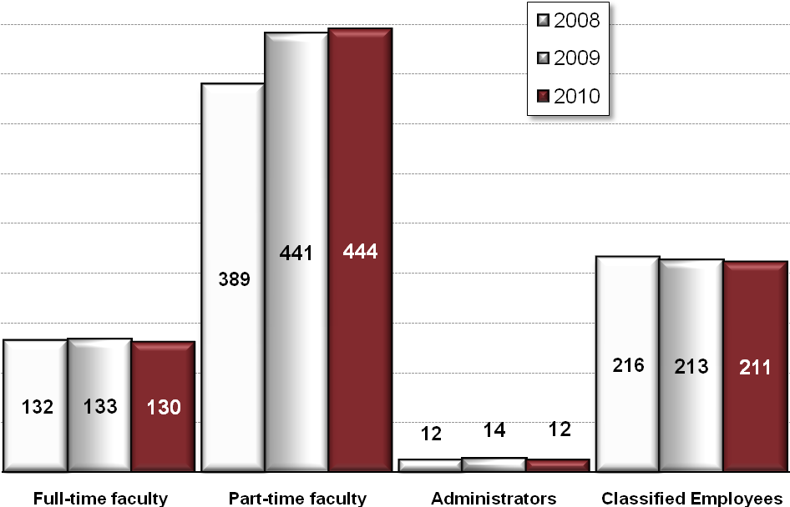
- On average, VVCC employs nearly 800 individuals each year.

FAST FACTS
- Established in 1961
- Accredited by WASC
- Total Enrollment
(2009-2010) = 19,439
- Full-time Equivalent Students
(2009-2010) = 10,022
DISTRICT BOUNDARIES
- The District is located in San Bernardino County, approximately 90 miles northeast of Los Angeles and 35 miles north of San Bernardino.
- Encompassing approximately 1,800 square miles, the District serves nearly 385,000 people in one of the largest geographical areas in the state.

CREATE A LIST OF WHAT YOU DO OR
SERVICES HERE.
• List your services or products here.

• List your services or products here.

• List your services or products here.

• List your services or products here.

• List your services or products here.

• List your services or products here.

• List your services or products here.

• List your services or products here.

PROGRAMS OF DISTINCTION
- High Caliber Nursing Program
Graduated 758 students over the last five years, and placement rates on the NCLEX-RN have consistently been above 85%.
- Model United Nations
A competitive exercise that gives our students the opportunity to represent countries throughout the world in problem-solving exercises. For the last five years, VVCC students have been awarded the two top awards that a delegation can receive at the annual conference in New York City.
- Performing Arts Center
Having completed a 20,563 square foot addition to the Performing Arts Center, this venue continues to represent the cultural center of the High Desert region.

ENROLLMENT TREND
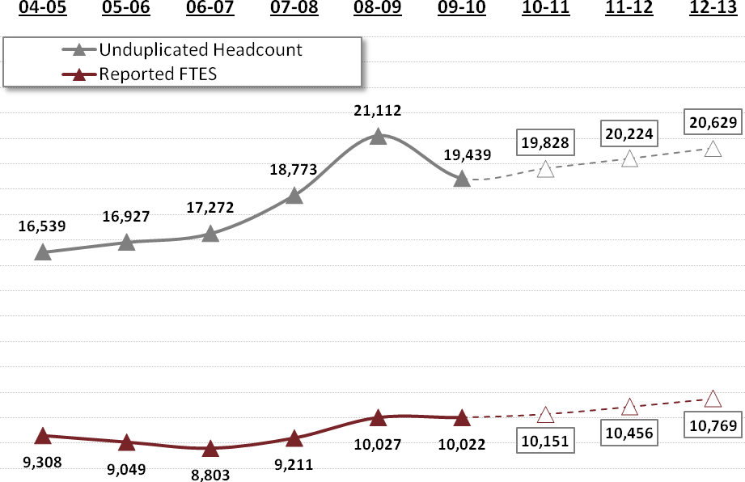
- Projected enrollments are depicted by boxes
- The pattern of increased full-time equivalents and decreases in unduplicated headcounts indicates students are taking higher loads – that is, they are more committed, focused, and pursuing specific educational /career goals.

GRADUATES
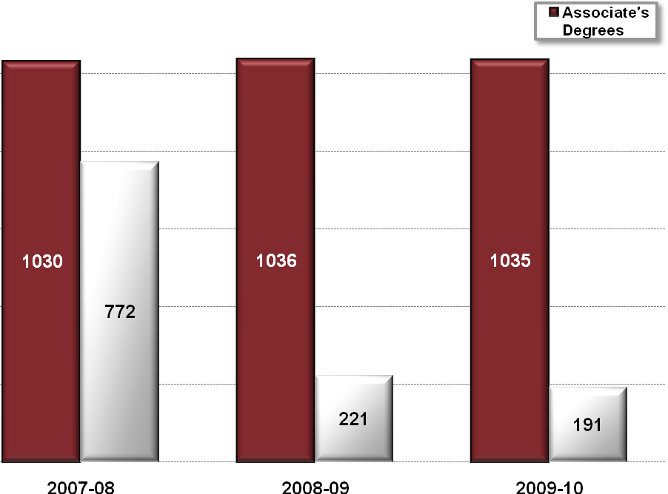

- Annually, VVCC graduates approximately 1,000 students with an associate’s degree.
- Decrease in certificates in 2008-2009 due to change in legal requirements to formally report low-credit certificates – those are still conferred but not reported to the state.

