VVC Safe Mobile Application - ANDROID

Android Application Installation Steps

- To download and install the VVC Safe Android application, open the below link in the mobile browser. - https://vvcsafe.vvc.edu/

- Select “Login” button to login to the website.

- Please use your VVC username and password to login to the VVC Safe web application.

- Please click on the “Victor Valley College” icon in the page as shown below to go to the Download section.
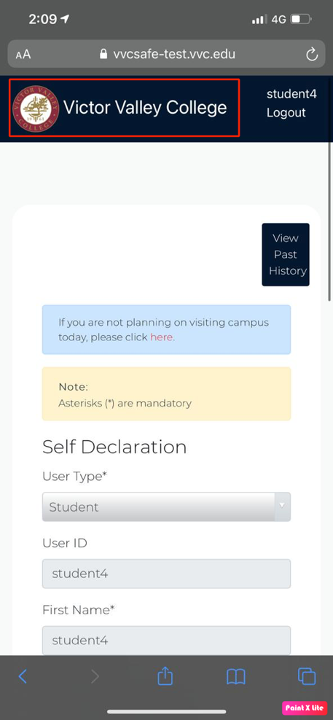

- Please click on the “Download Our Android App” icon to download the application. Then accept the “Download” on the mobile browser as shown below.

- Open the file “android_build.apk” file to install the application as shown below.

- Now please enable “Allow from this source” option to install the application. Here in this case “Chrome” browser.

- Please select “Install” now to install the application.

- Now the application will get installed.

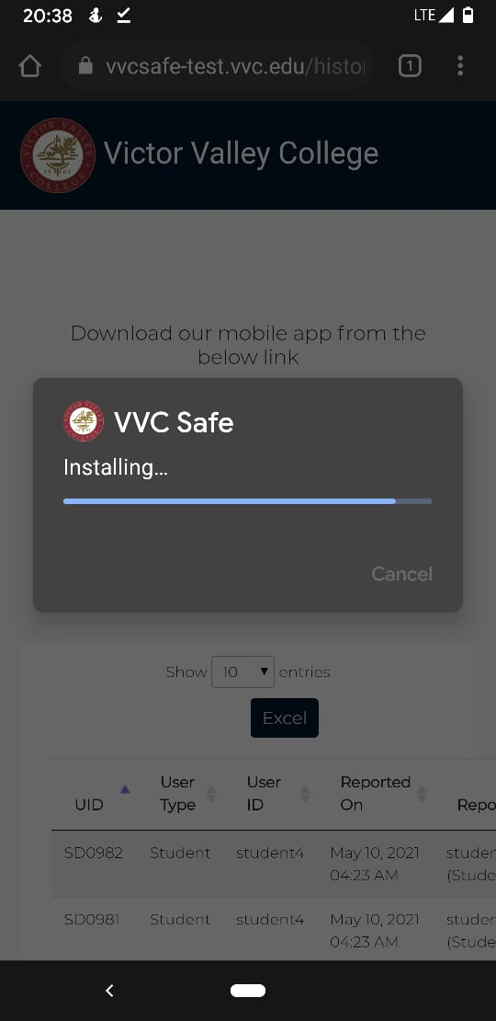

- Once the installation is completed, launch the VVC Safe application.

VVC Safe Application Login and Configuration Steps

- Launch the “VVC Safe” application in your mobile.

- Please select “While using the app” option for the device location services as shown below.

- Then click on the “Login” button.
- Click on the “Login here” link in the Classlink page as show below.

- In this page, please provide your VVC username and password, additionally provide the “VVC” as value in the “Code (Optional)” text box as show below and then click on “Sign In” button to continue.

- Now on successful login, you will be redirected to the below page. Please click “Continue” to enter into the application.

- Please make sure that the “Location” and “Bluetooth” services are enabled on the mobile phones.

- You can start using the application from here.

