VVC Safe Mobile Application - iPHONE

iOS Application Installation Steps

- To download and install the VVC Safe iOS application, open the below link in the mobile browser. – https://vvcsafe.vvc.edu/

- Select the “Login” button to login to the website.

- Please use your VVC username and password to login to the VVC Safe web application.

- Please click on the “Victor Valley College” icon in the page as shown below to go to the Download section.
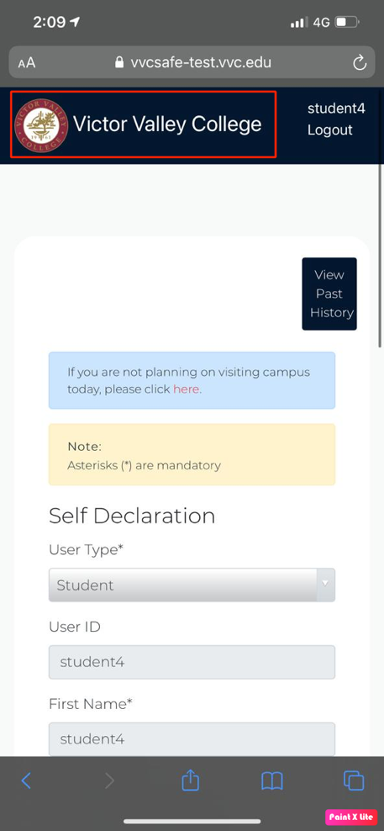

- Please click on the “Download Our iOS App” icon to download and install the application.

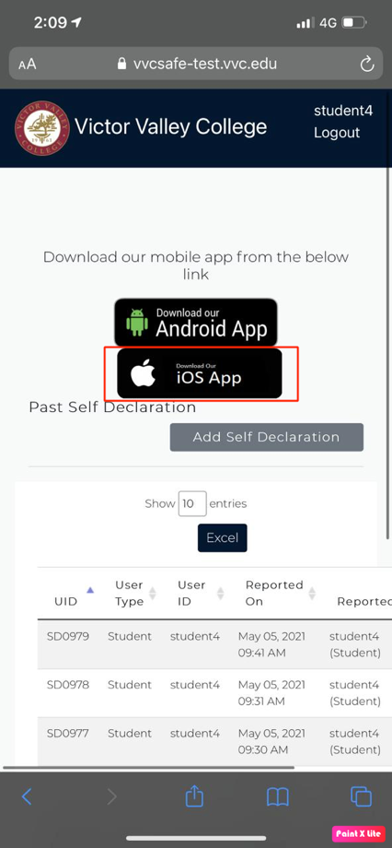

- Click on the “iOS App” icon to install the iOS application on your mobile.

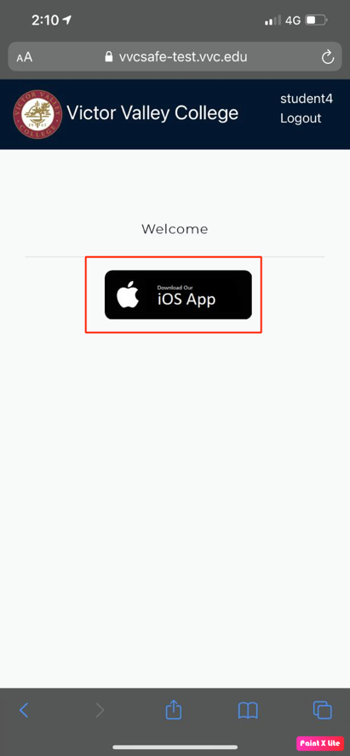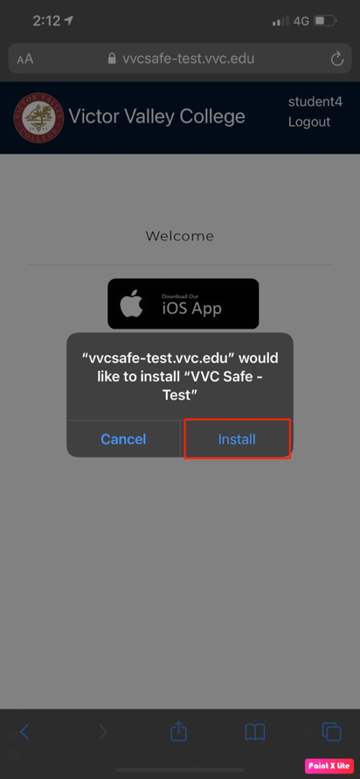
- To use the iOS application, the user must also manually trust the VVC organization before launching the app. Please follow these steps to trust your organization.

Note: An Internet connection is required to trust an enterprise developer.

- If you're behind a firewall, make sure it's configured to allow connections to https://ppq.apple.com.

- Please click on the “VVC Safe” application and then click “Cancel”. This step adds Device Management to Settings.

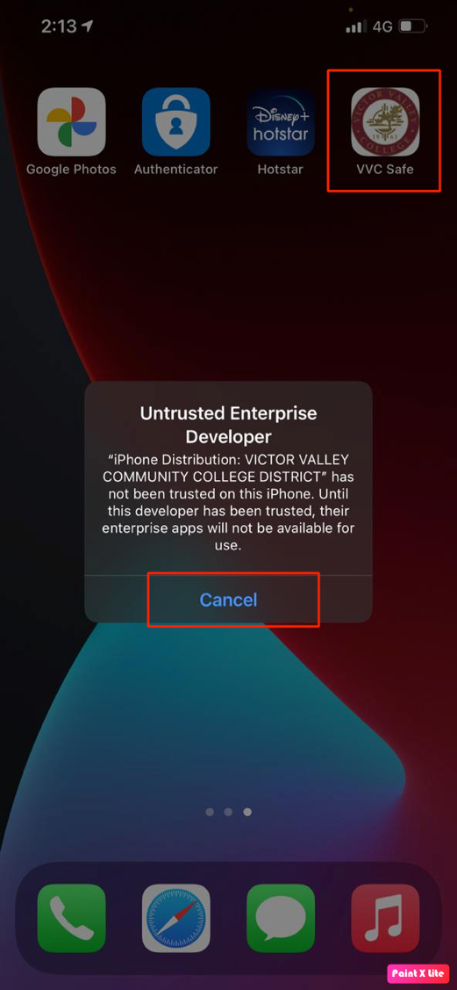

- Tap Settings > General > Device Management.

Note: If profiles are installed on your device, the setting is called Profiles & Device Management.

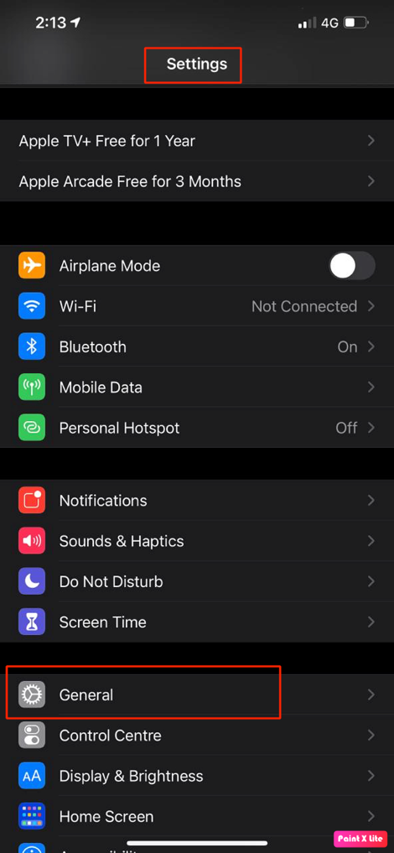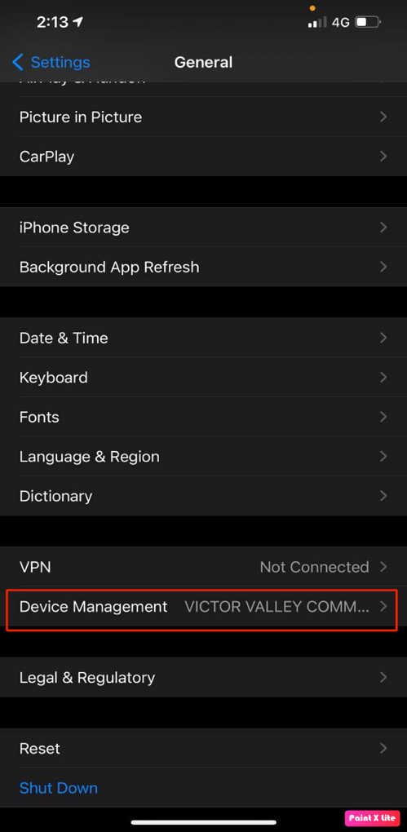

- Under Enterprise App, tap the organization name. Tap Trust "VICTOR VALLEY COMMUNITY COLLEGE". In the dialog that appears, tap Trust.

Note: If you are not connected to the Internet, a "Not Verified" message appears. Connect the device to the Internet and tap the Verify App button.

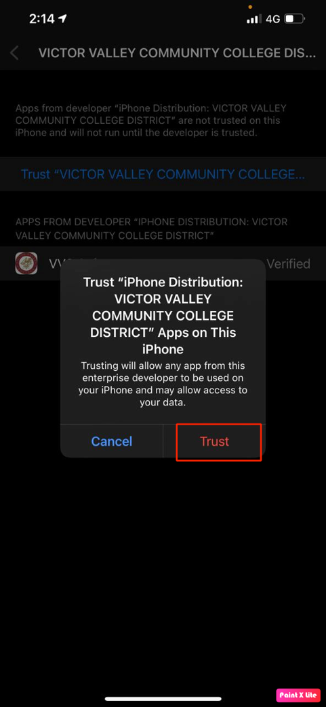

- The installation is now completed. Please launch the “VVC Safe” application to login.

VVC Safe Application Login and Configuration Steps

- Launch the “VVC Safe” application in your mobile.

- Please select “While using the app” option for the device location services as shown below.

- Then click on the “Login” button.

- Click on the “Login here” link in the Classlink page as show below.

- In this page, please provide your VVC username and password, additionally provide the “VVC” as value in the “Code (Optional)” text box as show below and then click on “Sign In” button to continue.

- Now on successful login, you will be redirected to the below page. Please click “Continue” to enter into the application.

- Please make sure that the “Location” and “Bluetooth” services are turned on the mobile phones.

- To enable “Always” access for “Location” In the iOS phone, please go to the “Settings” and select the “VVC Safe” application.

- Please provide the “Always” access for “Location” and enable “Notifications”. Once it is enabled, it will look like as shown below in the iOS phone.

- That’s all. Please start using the VVC Safe application.

