AUTO 79A
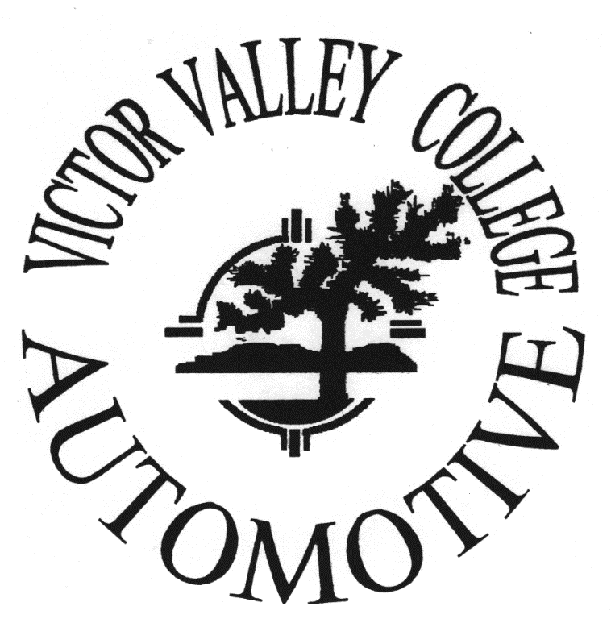
STUDENT PACKET
Basic Tune Up
Section Number 61143
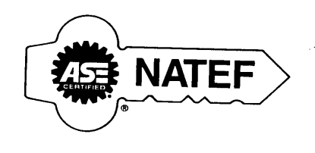

Instructors Note:
Most questions about Auto 79A will be answered
In this packet
Steve Lucas
Auto 79A Instructor

VICTOR VALLEY COLLEGE SYLLABUS
Spring 2017

VICTOR VALLEY COLLEGE SYLLABUS

SPRING 2017

Course No.: Auto 79A Course Title: Basic Tune Up Units: 2

Section No.: 61143 Class Hours: 8:00 – 4:00 Days: Saturday Room No.: Bldg 67 Room 1/ Bldg 64 Shop

Instructor Name: Steven Lucas Office No: 760-955-0058 Tel. Ext.: None

E-mail Address: steven.lucas@vvc.edu

SPRING CALENDAR
Spring Term Begins February 13
Presidents Day Lincoln February 17
College Closed (no classes) February 18
Presidents Day Washington February 20
Spring Break (no classes-offices open) April 10 – 14
Spring Break Holiday (college closed) April 14
College Closed (no classes) April 15
Memorial Day Holiday (college closed) May 29
Commencement June 9
Spring Semester Ends June 10
Sixteen (16) week term February 13 – June 10
Off-Campus Twelve (12) week term February 13 – May 13 (Does not follow VVC calendar, see that site’s calendar)
First Twelve (12) week term February 13 – May 13
Second Twelve (12) week term March 13 – June 10
First Eight (8) week term February 13 – April 8
Second Eight (8) week term April 18 – June 10

WITHDRAWAL POLICY
NOTE – CAMPUS IS CLOSED and CLASSES WILL NOT BE HELD ON CAMPUS THE FOLLOWING DATES:
February, 17th, 18th, 20th, April 10th, 11th, 12th, 13th, 14th, 15th, and May 29th
STATEMENT OF ACCESS: Students with special needs are encouraged to meet with instructors to discuss the opportunity for academic accommodation and referral to Disabled Students Programs and Services (DSPS) and services per Administrative Procedure (AP 3440)
Visit Victor Valley College online at www.vvc.edu

Prerequisite:
NONE

Textbook:
CDX (Minimum of 2 Scantrons Required)

Course Description:

This course covers basic techniques used by the automotive industry to diagnose and repair fuel and ignition systems. Topics cover the “basics” of conventional and electronic ignition systems, fuel systems, introduction to automotive computers, lubrication and cooling systems.

Course Objectives:
- Recognize and identify shop safety, environmental hazards and sustainable environmental practices in an automotive shop.
- Identify the different components of the ignition system.
- Identify the different components of the lubrication and cooling systems.
- Diagnose, disassemble, repair and reassemble components of the fuel delivery system.

Student Learning Outcomes:
- Safely and responsibly perform automotive repairs while minimizing impact on the environment.
- Determine necessary repairs to bring the engine into industry compliance for drivability and emissions.

Grading Policy:

Homework and Quizzes: 25%

Lab Work: 50%

Final Exam: 25%

90 -- 100% = A

80 –- 89% = B

70 --79% = C

60 –- 69% = D

Below 60% = F

Attendance Policy: (Class attendance is not a measure of performance or proficiency. Whether a student is just physically present in the class is not a valid basis for grading. Reference Title 5 Section 55002 of the California Code of Regulations: (A) Grading Policy. The course provides for measurement of student performance in terms of stated course objectives and culminates in a formal, permanently recorded grade based upon uniform standards in accordance with section 55758 of this Division. The grade is based on demonstrated proficiency in the subject matter and the ability to demonstrate that proficiency, at least in part, by means of written expression that may include essays, or, in courses where the curriculum committee deems them to be appropriate, by problem solving exercises or skills demonstrations by students.)

Safety: All students will be given thorough safety instructions and an S/P-2 safety test (must be passed with a grade of 80% or more before lab work is allowed). Log on to the Internet sp2.org. Your user name is 78442, your password is fact, and your pin is your last 6 digits of your student ID number. Read the information presented for S/P2 Training for Mechanical Repair Safety, S/P2 Training for Mechanical Repair Pollution Prevention and S/P2 Land that Job, take ALL the quizzes, and take both finals. All lab rules and safety practices must be followed. Failure to follow these rules is cause to be dropped from class. NOTE: All students are required to have and bring eye protection (no sun glasses) (eye protection will NOT be loaned from the tool crib) to all lab sessions. A student must put on their eye protection as they walk from the classroom into shop. Students must also wear nitrile gloves or other approved type gloves while working in automotive lab.

Blackboard

All assignments, course information and handouts will be available on Blackboard.

Go to the “quick links” section on the left hand side of the VVC website home page and click on blackboard. Follow instructions for logging in.

www.vvc.edu

TO ACCESS YOUR BLACKBOARD HOME PAGE, CLICK ON ACCESS BLACKBOARD NOW AND ENTER THE FOLLOWING AT THE LOGIN SCREEN:
- Your Username is:
  - Your seven-digit – complete student ID number (0123456)
- Your Password is:
  - Your six-digit birthdate (MMDDYY)
  - After Login, you can change your password

AUTO 79A
Week 1:
Feb. 25 Introduction to auto 79A, Teacher and Student introductions, SP-2 review and setup, Shop Safety, Hazardous Materials Waste Handling. Review of automotive shop rules and lab practices. Watch lift safety video and take lift safety exam. Discuss Vehicle Identification and VIN Breakdown

LAB WORK: Tour of Auto Shop, Lift demonstration and use / SP2 as needed.

Homework: Purchase CDX, Obtain Safety Glasses, Complete SP-2, Read 4 stroke engine theory “hand-out”, Complete Chapters 2 – into to auto, 8.1 – under hood inspection (chapter 8 study tools).

Week 2: Review 4 stroke engine theory, Review Chapters 2, 8.1. Mar.4

LAB WORK: Complete Fluid Check Activity, Vehicle ID and SP2 if needed.

Homework: Complete Chapter 45 – engine lubrication

Week 3: Review Chapter 45 – engine lubrication
Mar. 11
LAB WORK: Complete Oil Change Activity

Homework: Complete Chapter 46 – engine cooling

Week 4:
Mar. 18 Review chapter 46 – engine cooling
MID TERM TEST – SCANTRON REQ.

LAB WORK: Complete cooling system activity / If time permits, catch up on any activity sheets that are not completed up to date.

Homework: Complete Chapters 36 – Electrical Fundamentals and 38 - batteries

Week 5: Review Chapters 36 and 38
Mar. 25
LAB WORK: Battery maintenance, Charging system check / make up labs

Homework: Complete Chapters 44.2 – 4 stoke theory and 47 – ignition systems

Week 6: Review chapters 44.2 and 47
April 2

LAB WORK: Tune up and ignition system

Homework: Complete Chapter 48 – Fuel System

Week 7:
April 8 Review Chapter 48 – Fuel System.
Review for Final Exam

Final Exam. SCANTRON REQUIRED

Last Day of Semester

LAB WORK: Complete Fuel system activity.
All incomplete lab assignments DUE!!!!!

Victor Valley College Automotive Technology Department
Student Policies and Procedures
In addition to the following policies and procedure, students are governed by and expected to abide by the general rules, code of ethics and conducts of Victor Valley College. Please refer to the student handbook for complete information.
General Rules
- All repairs must be supervised by an instructor or qualified assistant designated by the instructor. The shop may not be used outside of regular scheduled class time or without the permission and presence of an instructor.
- If a student needs to leave the shop area during regular scheduled class time they are asked to inform the instructor.
- Student are encouraged and in some courses required to bring tools to lab sessions, however VVCC or its employees are not responsible for the theft of your tools. VVCC will provide an open top, unmonitored, locked tool storage area, however you are leaving locked toolboxes at your own risk. If you do not feel comfortable leaving your tools under these conditions you are encouraged to store them elsewhere.
- Only students that are currently enrolled in a class are permitted to be in a classroom, the auto shop library, parking area or in the auto shop work area.
- All hazardous waste including oil, brake fluids, oil filters, gasoline, solvents and any other substance generally considered by the State of California to be of a hazardous nature must be stored and disposed of properly, if you have questions contact the Automotive Instructional Assistance
- Students are encouraged to review the (MSDS) Material Safety Data Sheets before contacting any material or chemical in the shop. MSDS are located in the auto shop library.
- If a student leaves the lab, class or instruction area during class time the college or its employees does not assume any liability.
- Students enrolled in a class that is currently in session may borrow tools from the tool crib to use in the shop during that lab session. The student must return borrowed tools at the conclusion of that lab session. Tools are not to be removed from the lab area. The student that has borrowed the tool will be financial responsible for the tool if it is not returned to the tool crib at the end of the lab session or is damaged due to a negligence or mischief. Tools will be treated just like borrowed library books from the library, if the tool is not returned to the tool crib the corresponding replacement cost be be placed on the student's account until paid in full. Financial holds on accounts will result in the student losing the ability to register for classes, holds on graduation and transcripts or other holds as determined by the college. To borrow a tool the student must surrender their current semester Victor Valley College student Identification. No other form of identification can be used to borrow tools. (I.E) Students cannot borrow tools using a driver's license or state ID, cell phone or car keys. ETC.

Service Order Procedures and Lab Rules
- The instructor must approve all lab projects before work has begun.
- Students will not be permitted to work in the lab area until they have passed both SP2 automotive safety and pollution training courses and tests with a score of 80% or higher.
- All vehicles entering the auto shop parking area must have a current work order.
- Keys will be given to the service advisor and kept in a locked storage area for the duration of the vehicles stay in the automotive department. Keys can be checked out during lab sessions from the tool crib with a washer from the tool crib.
- Only vehicles with a current repair order will be permitted in the shop or rear parking areas. Student parking is provided in designated parking areas only.
- All vehicles must have steering wheel covers, seat cover, floor mats and fender covers applied before repair work is started.
- Students will be giving a technician work sheet and must document all work that is performed and all needed additional work on that sheet.
- An instructor must verify all repairs and the technician worksheet must be signed by the instructor before the repair order can be closed and the vehicles can leave the lab area.
- After repairs have been completed and repair orders have been closed vehicles must be removed from the shop and rear parking areas. Vehicle left without permission may be subject to impound.
- All lab projects including vehicles left beyond the last day of the term will assumed to be abandoned and will be disposed of properly and at the sole discretion of Victor Valley College.
- The instructor will have the ability to stop any project, assignment, repair or operation at anytime and for any reason if he or she feels that is being conducted in an unsafe manner, a safety rule is being violated, or it poses a hazard to anyone.
- The internet may be accessed in the computer lab of the automotive department during scheduled class time and only with the permission of the instructor. The following web sites are the only sites that may be accessed. Students found in violation of the internet rules or procedure will be subject to the following procedures or may be subject to immediate dismissal depending on the severity of the infraction.
- Respiratory protection is required whenever in the presence of vapors or airborne particulate matter of any kind
- Students are not permitted to use any piece of shop equipment without being properly trained on its usage and safety practices.
- Students are not permitted to drive or road test a vehicle without being accompanied by the instructor or Instructional Assistant. If the road test is with the instructional Assistant the student must acquire permission from the instructor.
- When road testing a vehicle all laws must be obeyed and the vehicle may not be operated in an unsafe manner.
- Students who do not possess a valid California driver’s license may not operate or sit in the driver’s seat of a vehicle.
- Before starting any vehicle ensure that both feet are in the vehicle, all doors are closed, seat belt is on and you are prepared to operate the vehicle.
- Wheels must be chocked on all vehicles before repair work is started.
- A shop exhaust ventilation hose must be connected to the exhaust pipe of any vehicle running in the auto shop.
- If a student doesn't understand the complete and safe operation of a piece of equipment, service operation or procedure it is not only their right but the responsibility of the student to stop and ask for proper training from an Instructor and Instruction Assistant before proceeding.

Personal Conduct and Behavior
- Profanity and inappropriate conversation is unprofessional and will not be permitted.
- In the Automotive Industry it is very important that you not only behave in a professional manner, but that you also look professional. Therefore the following mandatory dress policy must be followed:
  - The Victor Valley College Automotive Department Shirt must be worn to all lab and class sessions.
  - The designated department shirt must be clean, unwrinkled and worn properly at all times.
  - You must be bathed, clean, free of malodor, properly groomed and attired before coming to class. This determination will be made by the instructor and should be consistent with what an employer would expect during working hours.
  - Your hair must be neat and clean.
  - Fingernails must be clean and cut short. For Safety reasons acrylic are not allowed.
  - Students not abiding by these policies will be dismissed from class for the day and will not be allowed to make up missed work.
  - Any student who fails to conduct themselves in a professional manner will be removed from the class and forwarded to the Dean for corrective action.
  - Students are required to conduct themselves in a safe and professional manner when in the classroom, lab area and when on the VVCC campus.
  - Victor Valley College is a smoke-free institution. Smoking or the use of any tobacco products or smokeless devices such as e-cigarettes, is prohibited at all campus sites. Students, staff members and visitors to the campuses of Victor Valley College are permitted to use tobacco products or smokeless devices in their personal vehicles only.
  - Students are not permitted to take breaks in the rear parking area
  - Eating or drinking is not permitted in the shop, library/computer lab, or the rear parking area.
  - Thievery of any kind is against department and college rules.
  - Safety glasses are required when in the shop, whether working on a lab project or not. Smoked colored glasses, sunglasses, and some tinted glasses do not meet the auto shop standard. Please see instructor before purchasing glasses for proper identification. The instructor will have final say on what is or is not safe and appropriate. Some operations may require the additional use of a complete safety shield or tinted lenses for welding or cutting.
  - Proper close-toed shoes are required in the lab area.
  - Short pants are not permitted in the lab area.
  - Loose or baggy clothing is not recommended and may be unsafe. The instructor will have final say on what is or is not safe and appropriate.
Shop Cleanup and Maintenance
- Students are responsible for keeping and maintaining a clean lab area while working in lab.
- Each class will both sweep and mop the entire shop at the end of each lab session.
- Students are to ensure that all lab areas are thoroughly cleaned before leaving the lab area.
- Cleaning up oil spills from the shop floor:
  - Apply oil absorbent to oil spill and allow sufficient time for oil absorbent to absorb fluid.
  - Sweep up and either recycle or dispose of absorbent in oil absorbent disposal container.
  - Wipe up remaining residue with shop rags and recycle shop rags.
  - After determining floor is free of oil, mop floor with hot soapy water.
  - After ensuring mop water is free of contaminates, dispose of mop water in shop sink.
  - After disposing of used mop water thoroughly clean mop head and bucket and return empty bucket and clean mop to storage rack. Ensure that mop is returned to the hanging position to ensure that it dries.
  - (Please not that complete shop cleaning instructions are contained the in Shop Maintenance guide, however due to the legality of waste oil disposal a brief explanation was given here.)
- All vehicle must be removed from the shop and work areas, parked and locked at the end of the lab session.
- All benches must be cleaned and returned to the proper area at the end of the lab session.
- Food and drinks are not allowed in the computer or service advisor areas.
- Please notify your instructor and the instructional assistant in the event of a large hazardous materials spill.

Attendance
- All students enrolled in a lecture or lab class are required to “clock in” upon their arrival and “clock out” upon their departure from class. This time card will serve as the official attendance record for the course. It is the responsibility of the student to ensure that this task is completed during every class session.

Victor Valley Community College
Automotive Department
Shop Cleaning Program
It is important that the shop be kept clean at all times. This makes the shop a safe environment for all students and faculty. You will find that most shops require their employees to keep a clean work area. Your first job may be cleaning a shop. You will find that if you take the time to clean up at the end of the day, you start the next day ready to work as soon as you arrive. Your work area is safer and you work more efficiently.
Students are required to wear safety glasses while in the shop. As you are cleaning, move equipment and clean under it. If you desire to use compressed air, air nozzles are available in the tool crib. If you are not sure how to clean an area or equipment, feel free to ask an Instructor Assistant or an Instructor.
The cleaning tasks in the Automotive Department are divided into areas.
- Entry area and service writing desk
- main shop
- Equipment, fixed and movable
- Alignment racks
- Concrete apron outside the roll up doors
- Machine shop
- Tables
Mopping Procedure
- Take a mop and bucket to the janitor’s closet
- Fill the bucket with hot water
- Dip the mop head in the water and wring it out.
- Mop the floor while dipping the mop head in the water as needed
- When you are finished, empty the mop bucket in the sink
- Rinse out the mop head and bucket
- Hang the mop over the empty mop bucket on the rack, mop head down

Procedure for Cleaning Spilled Liquids
- Sprinkle the absorbent on the area of the spill
- Wait a few minutes for the absorbent to work.
- Sweep up the absorbent and place it in the used absorbent container
- Wipe up remaining residue with shop rags
- Ensure that the floor is free of oil reside or other hazardous waste.
- Mop area with Hot water
- Dispose of water in shop sink located in janitor’s area.

Sweeping Shop Floor
- Brooms are located in the janitor’s closet next to the tool crib
- Sweep from the area of the tool crib out to the Roll up Doors.
- Use compressed air to clean around fixed equipment
- If it is windy, close the doors and work toward the classroom
- Return broom to janitor’s Closet

Equipment, Tables and Tire Machines
- Obtain a bottle of spray cleaner and a blues shop rag from the tool crib
- Spray the surface and wipe clean, it may take more than one rag to get the surface clean

Alignment Racks
- Wipe down the metal surfaces
- Raise the racks and clean the floor with a mop and hot water

Concrete Apron
- Sweep to the edge where the asphalt begins
- Mop the concrete surface in the same manner as the shop floor

