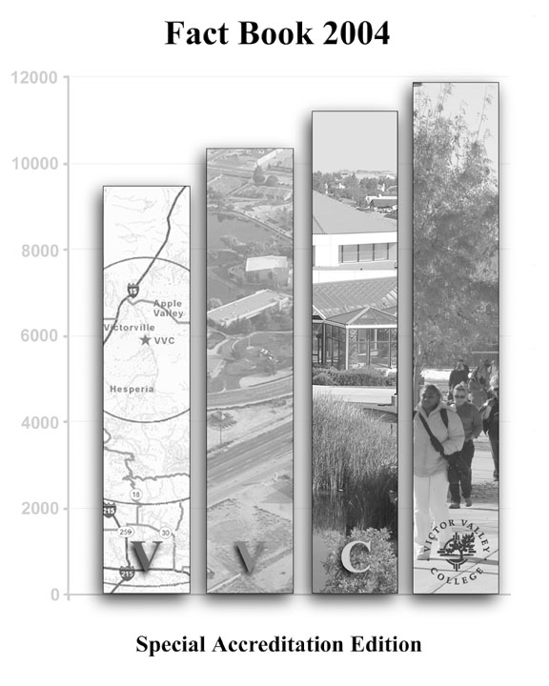

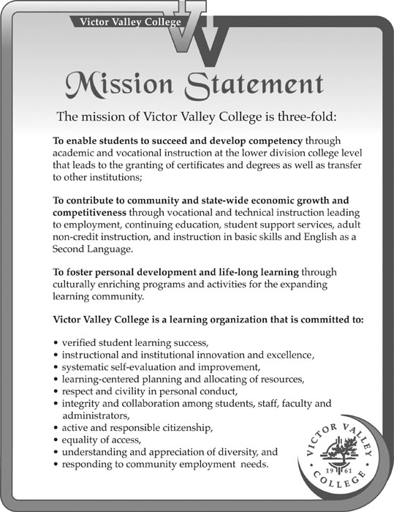

Victor Valley College Board of Trustees

Joe Range……………….…………President
Dennis Henderson……………Vice President
Bettye Underhill, Ph.D…………………Clerk
Thomas M. Elder II……….……….….Trustee
Dorothy N. Franke, Ph.D….………….Trustee
Eddie Miro……………………ASB President

Victor Valley College Administration

Patricia A. Spencer, Ph.D. ……………………..…………….Superintendent/President
Jeff Cooper….……...….Deputy/Superintendent, Executive Vice President, Instruction
Willard Clark Lewallen, Ph.D. ……………………….Vice President, Student Services
Bruce Baron.……………………………….…Vice President, Administrative Services
Richard Porter……. ….………………………………..Interim Dean, Student Services
Thomas O’Neil, Ph.D. ….…Dean, Academic Programs, Humanities & Social Science
Nick Parisi…………………………………………………Dean, Vocational Education
Henry Yong……………..………………..Dean, Academic Programs, Math & Science

Accreditation Statement

Victor Valley College is accredited by the Western Association of Schools and Colleges approved by the California State Department of Education.

Accrediting Commission for Community and Junior Colleges:
Western Association of Schools and Colleges
3402 Mendocino Ave, Santa Rosa, CA 95403
(707) 569-9177 Fax (707) 569-9179



Victor Valley College
18422 Bear Valley Rd.
Victorville, CA 92392-5849
(760) 245-4271
www.vvc.edu

Cover © Jeremy Nissen 2004



Mission and Purpose

The mission of the Office of Institutional Research, aligned with the mission and institutional commitment of Victor Valley College, is to support the district in its evaluation, planning and improvement efforts. Primary focus is placed on the assessment of student learning outcomes and the integrity of data as delivered to Victor Valley College’s internal and external stakeholders.

Activities

- Design, conduct, and publish statistical studies to assist District policies, program planning, and development.
- Design, conduct, and publish on-demand studies to meet departmental, institutional, community, state and federally mandated needs.
- Provide assistance, guidance, and support to faculty, staff, and administrators in the conduct of their research activities and coordinate District and College-related research efforts.
- Maintain the Decision Support System allowing users to access student and course data via the web.
- Provide the community with information via the Institutional Research Website and an annual FactBook.

Published by: Institutional Research
Mark Clair: Institutional Research Coordinator ext. 2648
Willard C. Lewallen: Vice President, Student Services
Jeremy Nissen: Research Student Worker
This publication offered in an alternate format at www.vvc.edu/offices/research/IRwebsite04
Table of Contents

- What’s New in This Edition . . . . . . . . . . . . . . . . . . . . . . . . . . . . . . . . 01

- Descriptive Background . . . . . . . . . . . . . . . . . . . . . . . . . . . . . . . . . . . 02 - 04

- Community Forecast . . . . . . . . . . . . . . . . . . . . . . . . . . . . . . . . . . . . . . 05 - 08

- Community Connectedness . . . . . . . . . . . . . . . . . . . . . . . . . . . . . . . . . 09 - 11

- Enrollment Trends . . . . . . . . . . . . . . . . . . . . . . . . . . . . . . . . . . . . . . . . 12 - 19

- Enrollment Projections . . . . . . . . . . . . . . . . . . . . . . . . . . . . . . . . . . . . 20 - 21

- Student Demographics . . . . . . . . . . . . . . . . . . . . . . . . . . . . . . . . . . . . 22 - 26

- Student Achievement . . . . . . . . . . . . . . . . . . . . . . . . . . . . . . . . . . . . . 27 - 45

- Student and Staff Diversity . . . . . . . . . . . . . . . . . . . . . . . . . . . . . . . . . 46 - 47

What’s New in the 2004 FactBook

- Expanded description of the service area (ESRI map)

- Labor market information

- Expanded “Quick Facts” to include Spring and Summer

- Expanded student demographics section to include:

  - Major
  - Primary language
  - Average Work Hour/Week During Planned Semester of Enrollment
  - Educational Status
  - Educational Goal

- Expanded student achievement section to include:

  - Trends for retention and success
  - Retention by method of instruction
  - Success rate by method of instruction
  - Retention and success by type of course, gender, race, and age
  - Trends for GPA
  - Trends for persistence
  - Degrees and certificates by race and gender
  - Projected change in awards
  - Trends for transfer-ready students
  - VVC transfers through the National Student Clearinghouse
  - Nursing graduates and pass rates
  - Respiratory therapy licensures by year

Our Community, Our Students,
Our Staff – Our Future

Descriptive Background
Clean air, sunny days and clear, star-studded nights complement the unusual, natural beauty of the High Desert, which is the home of Victor Valley College. Around the campus is a landscape ringed with nearby mountains and Joshua trees, featuring spectacular explosions of beautiful desert wild flowers in the spring.
Victor Valley College is one of the most modern of the 109 community colleges in California. For more than 40 years, the history of the college has been entwined with the rich heritage and history of the High Desert and its people.
Located approximately 90 miles north of Los Angeles and 195 miles southeast of Las Vegas along interstate 15, Victor Valley College serves one of the largest geographical areas in the state and one first settled more than a hundred years ago by California gold miners, trappers, ranchers, merchants and railroad men.
Within the Inland Empire, the boundaries of the Victor Valley Community College District include an area of some 2,200 square miles drawing students from Adelanto, Apple Valley, Victorville, Helendale, Hesperia, Lucerne Valley, Oro Grande, Phelan, Piñon Hills, and Wrightwood (see Figure 1).

Figure 1: Site Map of Victor Valley (Approximate service area included in the 20 mile radius)
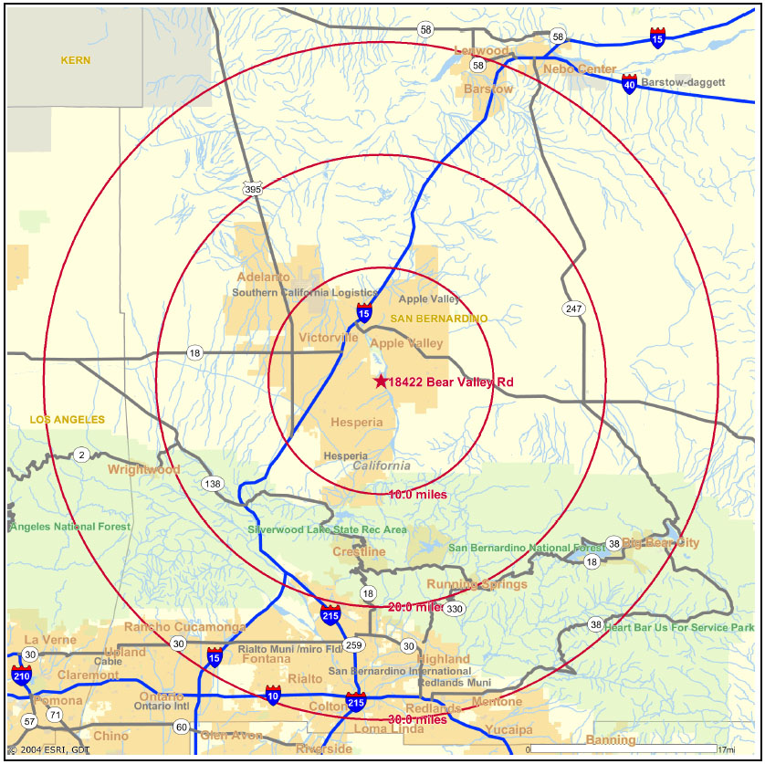
ESRI_map.jpg

Victorville itself, site of the college and the commercial hub of the High Desert area, was originally a trading post. Victorville’s first European inhabitants were merchants who provided a stream of railroaders, farmers and miners with the necessities of life such as ammunition, postal service and provisions.
Victor Valley College has at its core the fundamental elements and history of the California community college movement, which began around 1910.
The Victor Valley Community College District was created by a vote of the public in 1960, when voters enthusiastically approved the creation of a new community college district to educate local students.
The first classes at the college were held in 1961 on the campus of Victor Valley High School and included a small student body of only 500 students and a 15-member faculty and staff. Construction began in 1963 on the present campus, which encompasses 253 acres.
In 1965, the new Victor Valley College campus opened its doors to students. An expanded technical complex followed in 1979. In 1981, the Performing Arts Center was opened for the use of students and the High Desert community. In addition, a new Allied Health Building opened in 1983, in 1988 the Student Services Building was completed, and in 1991 the college campus became part of the city of Victorville.
In the mid 1990s, the campus experienced additional growth when the following projects were completed: new gymnasium, science building, library, construction technology building, additional parking lots, tennis courts, a student activities center, and an elevator connecting the lower and upper campus, which is separated by a 50ft. elevation difference. The old library was remodeled into an academic commons, housing a learning center for tutoring, Business Education Technology (BET), Computer Information Services (CIS) laboratories, and faculty offices. Two former classroom buildings have been remodeled and transformed into student services buildings providing improved access and convenience. Construction of a new Child Development Center was completed in 2002 and shortly after new soccer fields were available for play. An aerial view of the college campus in 2003 is depicted in Figure 2.
On the horizon are a major classroom building with over 900 computer-learning stations, a dramatic arts/speech addition to the Performing Arts Center, and new softball fields.

Demographic Information (In brief)
A campus that once served 500 students in 1961, now serves nearly 11,000 credit students each term. These students take advantage of what this institution has to offer enrolling in comprehensive educational programs in a wide number of academic, vocational and community service areas.
The students at Victor Valley College reflect the diversity of the surrounding community. Between Fall 1999 and Fall 2003, the percentage of African American, Asian, Hispanic, and American Indian/Pacific Islander students has increased from 35.2% to 38.6%. The African American population has increased from 9.0% to 9.6%; the Hispanic population has risen from 21.2% to 24.2%, while the White population has decreased from 64.0% to 59.4%.
The College opened in 1961 with 12 full-time instructors, 10 part-time instructors and 2.4 administrators. Since its inception, the College has maintained high standards of instruction and an array of services to students. As of Fall 2003, the staff has grown to 136 full-time instructors, 324 part-time instructors, and 181 classified support personnel. The demographic profile of the staff include 48.4% female, with the racial breakdown being 77.8% White, 10.6% Hispanic, 4.5% Asian/Pacific Islander, 5.8% African American, and 1.1% American Indian.

Figure 2: Aerial view of the Victor Valley College campus
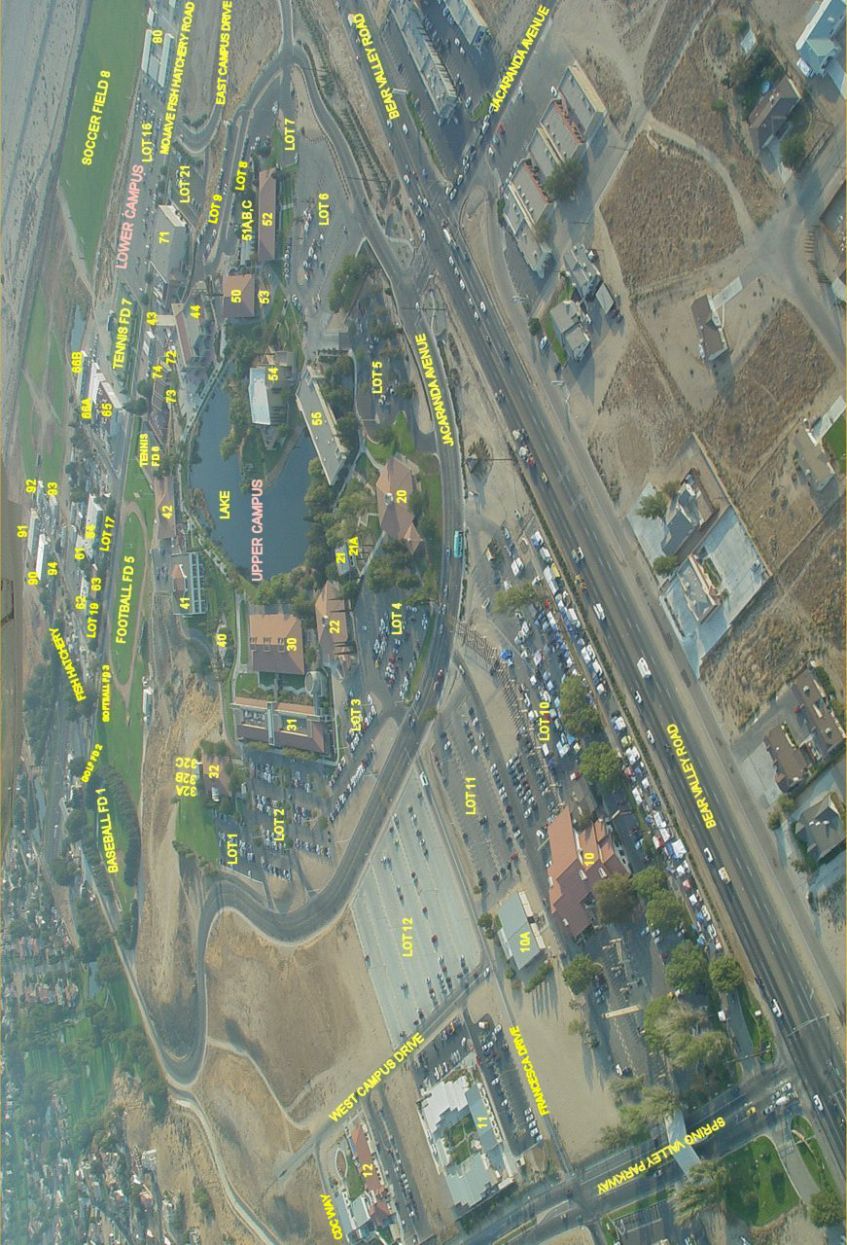
aerial.jpg

Community Forecast

According to the author of the Inland Empire Quarterly Economic report 2004, John Husing, the Inland Empire is forecasted to add 1.7 million people by 2020. As depicted in Table 1, considerable population increases have been viewed since 2000 (e.g. Victorville’s population grew 5.3% from 2000 to 2001) and more recent years show a similar trend. Victor Valley College has shared in this population growth as seen by an increase in enrollment of 12.0% from 2000 to 2003 (see Figure 3).

Table 1: Population Trends (1994 – 2003)
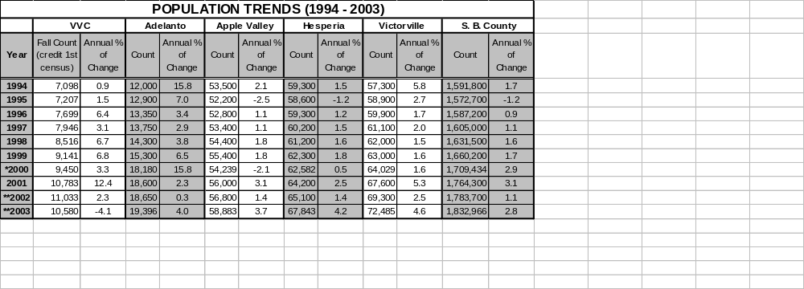Source: *County of San Bernardino: Department of Economic and Community Development pop_trends_ethnicity_age.xls Note: 1994 – 1999 and 2001 are projections provided by California State Department of Finance
**County of San Bernardino: Community Profiles 2002, 2003
http://www.co.san-bernardino.ca.us/ecd 2002 Demographic Profile

7,098
7,207
7,699
7,946
8,516
9,141
9,450
10,783
11,033
10,580
150,000
160,000
170,000
180,000
190,000
200,000
210,000
220,000
1994
1995
1996
1997
1998
1999
2000
2001
2002
2003
0
2,000
4,000
6,000
8,000
10,000
12,000
Incorporated Areas
VVC

Figure 3: Population Trends (VVC vs. Incorporated areas of Victor Valley
pop_trends.xls

Several influential factors have aided in this growth and will continue to benefit the Victor Valley for years to come. For example, The Victor Valley (e.g. Adelanto, Apple Valley, Hesperia, and Victorville) is now considered a “hot zone” for affordable housing in Southern California. For example, 604 home sales were recorded in the first quarter of 2004, which was the largest number of sales in San Bernardino County (Husing, 2004). As viewed in Figure 4, housing costs are increasing dramatically in San Bernardino County. Yet, as of July of 2004 the Victor Valley area continued to offer median home prices ($164,000 - $203,000) well below the median home price in California ($406,000). In addition, industrial space in the Inland Empire is the cheapest in Southern California allowing for the influx of new businesses (Husing, 2004).

Figure 4: San Bernardino County Median Home Price (2004)
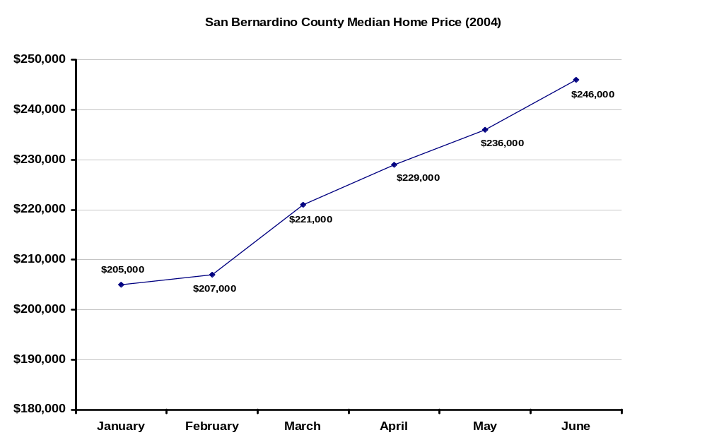
Median_house_price.xls

With 29,200 jobs projected for the Inland Empire in 2004 alone, 377,200 jobs are projected for this region by the year 2010 (Husing, 2004). Victor Valley College is positioning itself to play a key role in training the workforce needed for the growing population in the Victor Valley. Placement into many of the occupations (e.g. information technology, construction) listed in Table 2 will be possible through training at Victor Valley College. In fact, future employees could benefit from training at Victor Valley College for all of the top ten occupations with the fastest growth and those occupations with the most job openings in San Bernardino County as viewed in Table 3.

Table 2: San Bernardino County Occupations With The Fastest Job Growth (2001-2008)
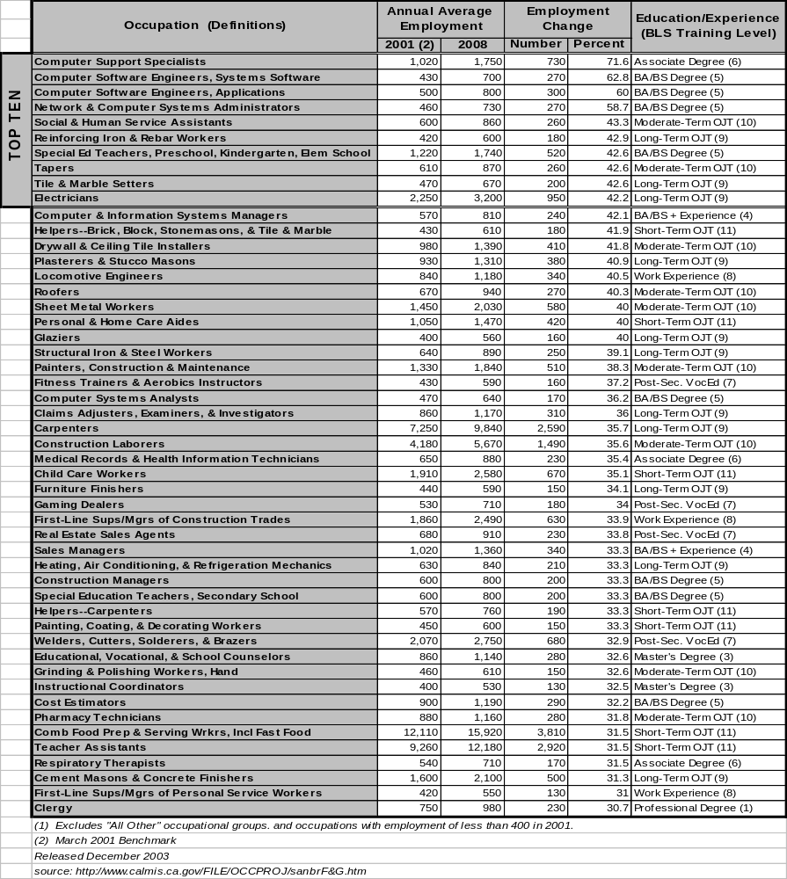
(1) Excludes “All Other” occupational groups, and occupations with employment of less than 400 in 2001.
(2) March 2001 Benchmark
Released December 2003
Source: http://www.calmis.ca.gov/FILE/OCCPRO/sanbrF&G.htm labor_market_fastest_growth.xls

Table 3: San Bernardino County Occupations With The Most Job Openings (2001-2008)
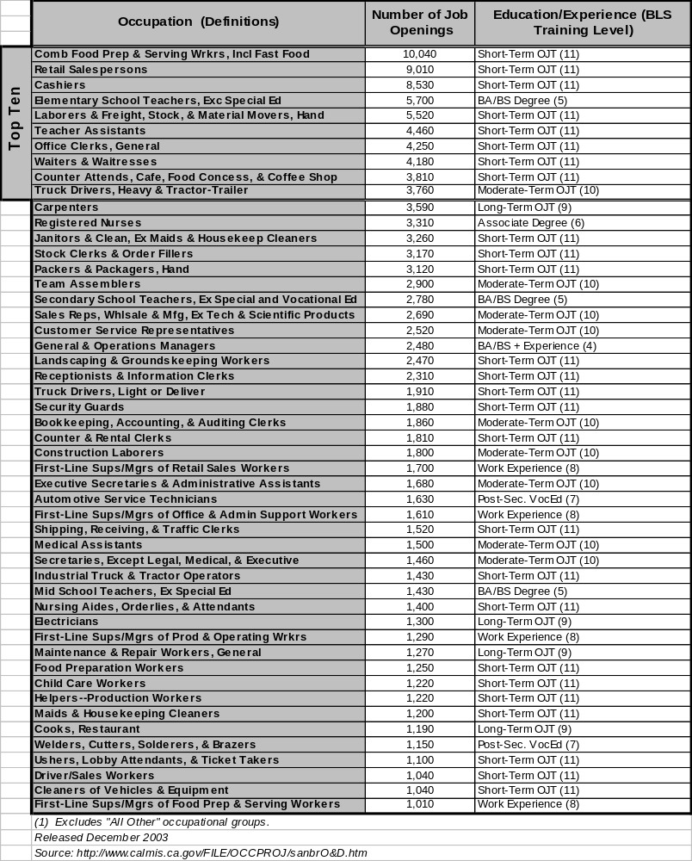
(1) Excludes “All Other” occupational groups.
Released December 2003
Source: http://www.calmis.ca.gov/FILE/OCCPROJ/sanbrO&D.htm labor_market_most_job_openings.xls

Community Connectedness

As part of the Student Equity Plan, Victor Valley College has identified specific populations to focus our outreach efforts. Even though the proportion has increased substantially over the last few years, the Hispanic population continues to be underrepresented as depicted in Figure 5.

Figure 5: Race/Ethnicity Distribution: VVC vs. Victor Valley

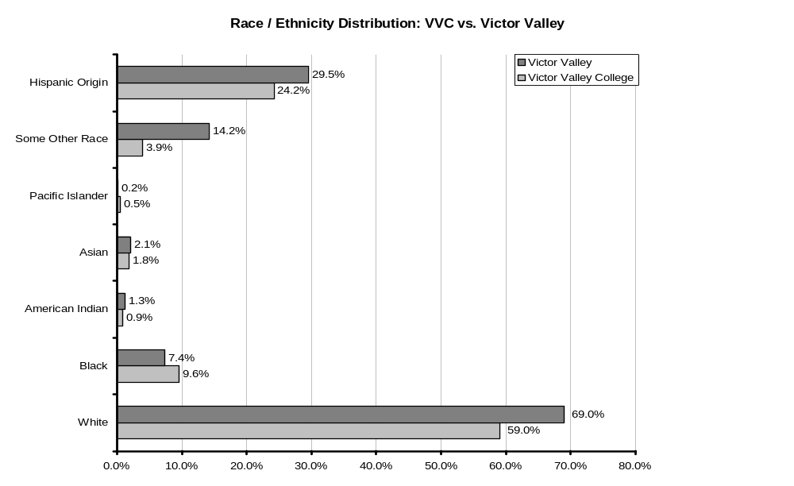
Source: U.S. Census Bureau, Census 2000 pop_trends_ethnicity_age.xls
VVC data is credit, 1st census Fall 2003
Note: The category "Two or More Races" was eliminated. Percentages for Victor Valley equate to over 100% due to the Hispanic category being of any race.



As viewed in Figure 6, over 60% of VVC’s students are female whereas females in the community account for half of the population.

Figure 6: Gender Distribution: VVC vs. Victor Valley
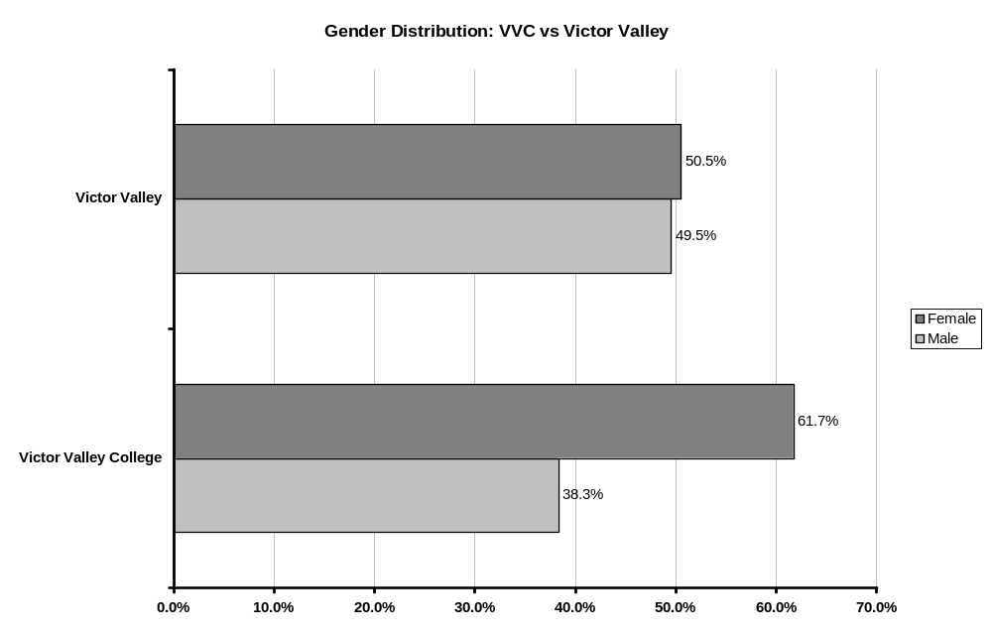
Source: ESRI 2003 estimate. gender.xls
VVC data is credit, 1st census Fall 2003

As shown in Figure 7, VVC primarily serves students between the ages of 15 and 54 (96.4%).

Figure 7: Age Distribution: VVC vs. Victor Valley
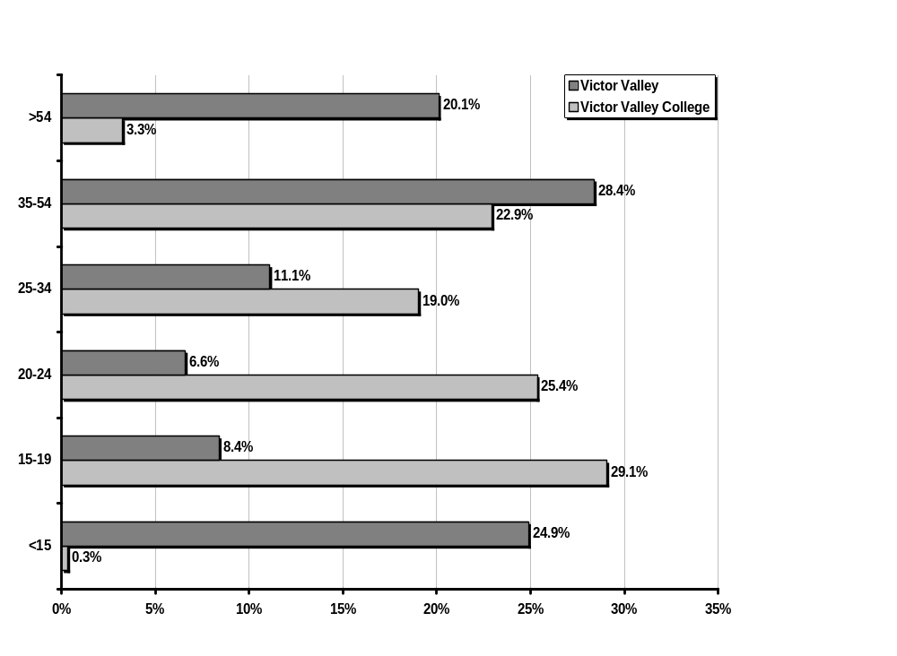
Source: U.S. Census Bureau, Census 2000 pop_trends_ethnicity_age.xls
VVC data is credit, 1st census Fall 2003

VVC is preparing for a substantial influx of students in the near future. While the number of graduates in our feeder public schools is projected to increase by nearly 10% by 2005, those attending VVC in the year in which they graduate is anticipated to increase by 39.5% by 2005 (see Figure 8).

Figure 8: Public High School Graduates: Projected Growth of Service Area
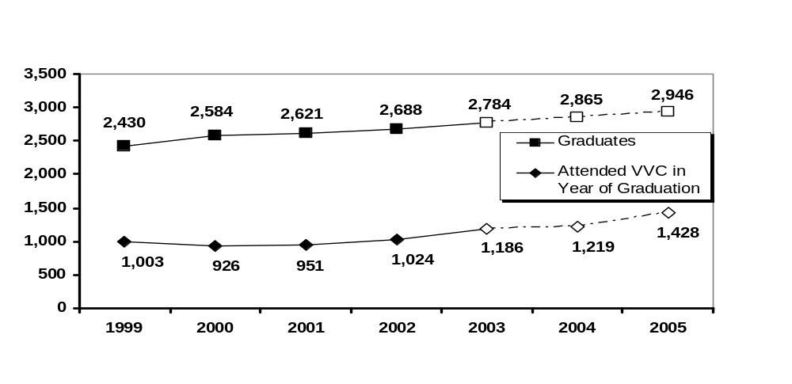
NOTE: Empty characters reveal projections projected_growth.xls

As revealed in Table 4, the number of graduates entering VVC from feeder high schools increased 7.7% from 2001 to 2002. Of interest, in 2002, 28.2% more graduates from Hesperia High School entered VVC then the previous year.

Table 4: Graduates Attending VVC Directly After High School
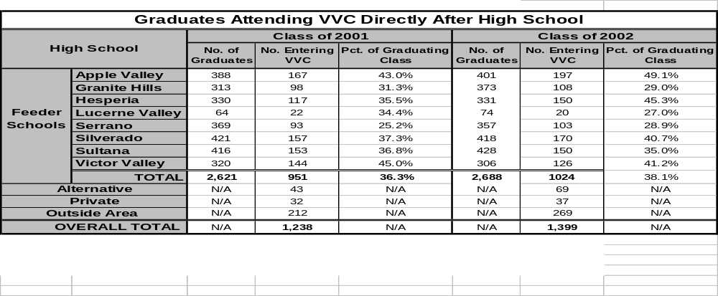
student_origins.xls

Enrollment Trends

The average percent increase between 1994 and 2002 was 5.7% for the Fall semesters. A similar increase was viewed in the Spring semesters (6.7%) between 1995 and 2003. The Summer intersession has grown considerably. For instance, an increase of 164.8% is viewed between 1994 and 2002 (see Figures 9-11).

Figure 9: Fall Unduplicated Headcount (1st Census)
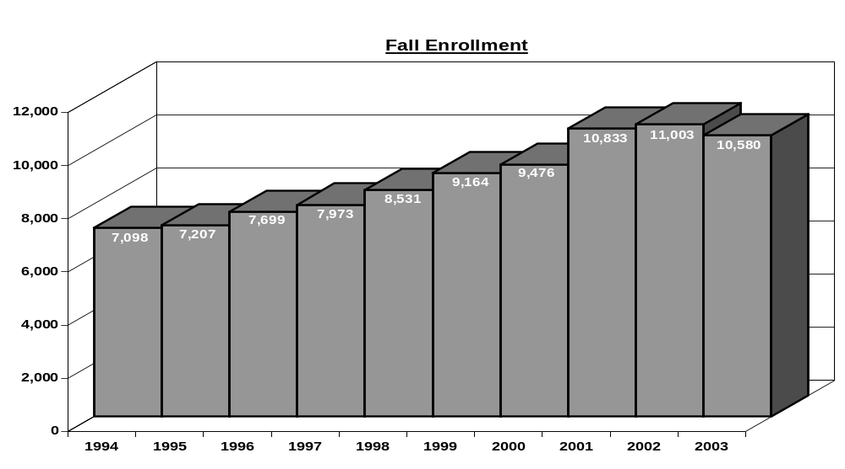
10yearheadcount.xls

Figure 10: Spring Unduplicated Headcount (1st Census)
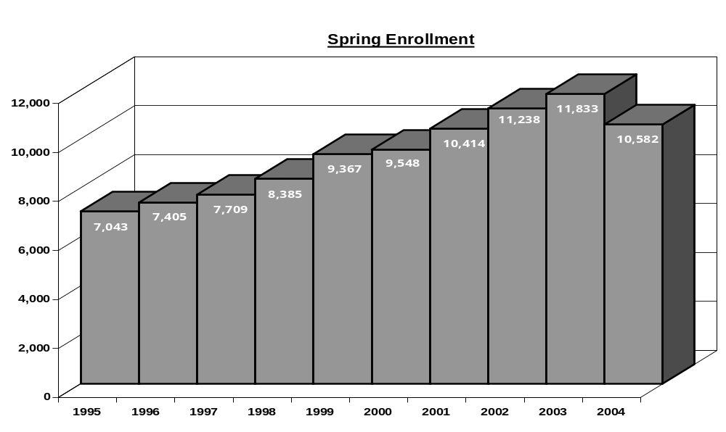
10yearheadcount.xls

Figure 11: Summer Unduplicated Headcount (1st Census)
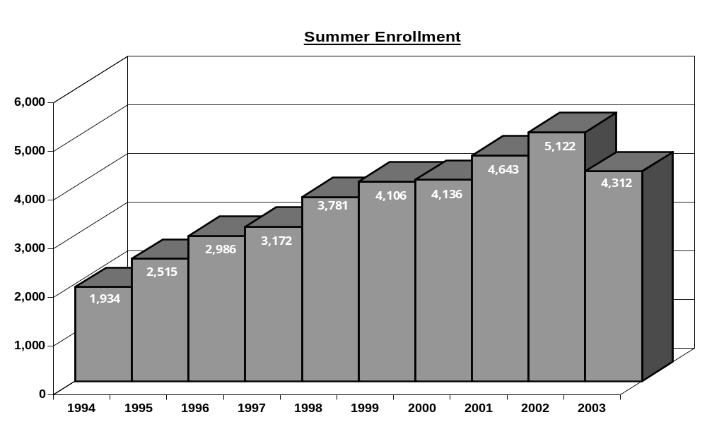
10yearheadcount.xls



As depicted in Table 5, from 1994 to 2003, the largest percentage point increase by age group was viewed in the 18-20 range (e.g. Spring = 3.6%, Summer = 2.7%, Fall = 6.8%). During this same time period, the largest percentage point decrease by age group was viewed in the 31–40 range (e.g. Spring = 8.2%, Summer = 5.0%, Fall = 8.7%).

Table 5: Unduplicated Headcount (1st Census) - Age
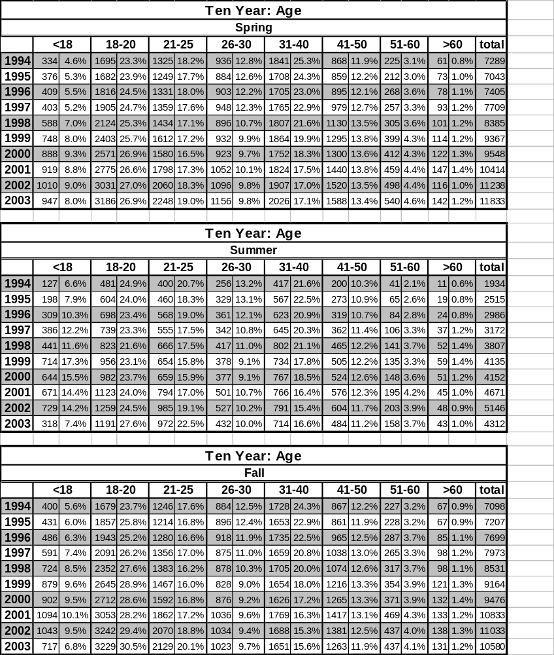
4 unknowns – spring 94 ; 1 unknown – summer 94 10yearage.xls

Gender proportions have changed very little over the ten years. The average proportion of females ranged from 59.5% to 62.1% for all three terms. Of interest is the year 2000 where gender proportions were least disparate for Spring (13.4%) and Summer (16.4%) (see Figures 12-14).

Figure 12: Fall Unduplicated Headcount (1st Census) - Gender
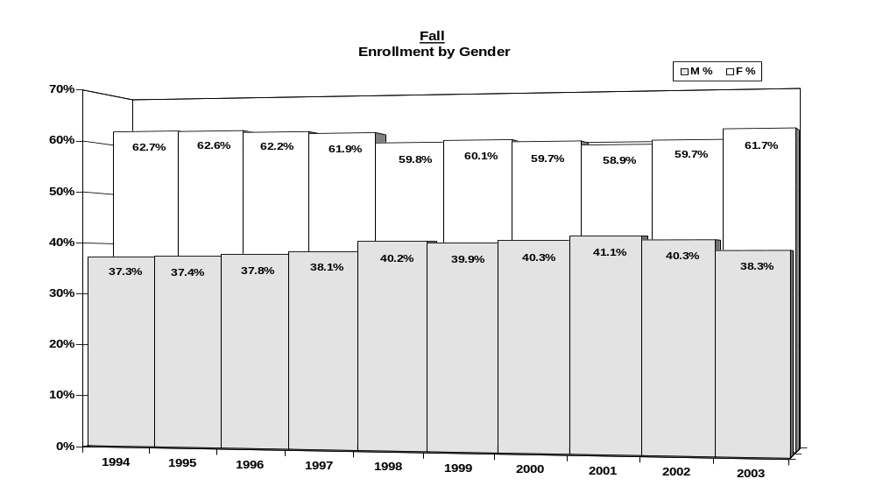
10yeargender.xls

Figure 13: Spring Unduplicated Headcount (1st Census) - Gender

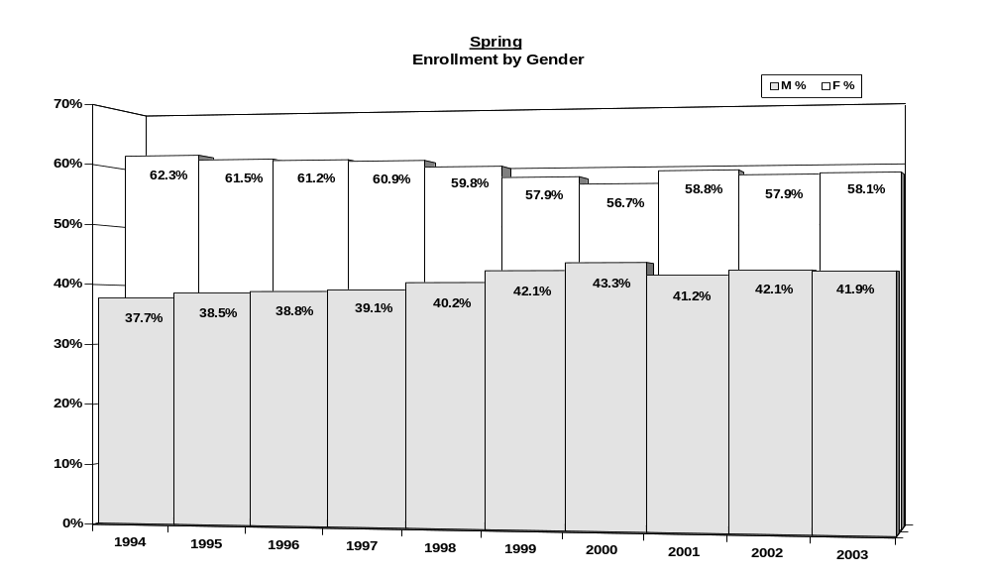
10yeargender.xls

Figure 14: Summer Unduplicated Headcount (1st Census) - Gender

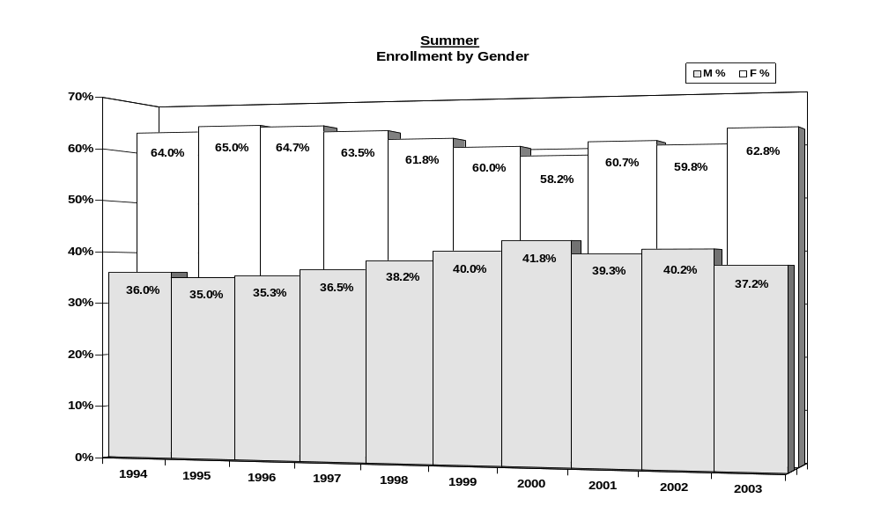
10yeargender.xls



Figure 15 reveals a net percent increase of 39.1% for Hispanics from 1994 to 2003. During this same time period, a net percent decrease of 16.0% is shown for Whites.

Figure 15: Fall Unduplicated Headcount (1st Census) – Race/Ethnicity
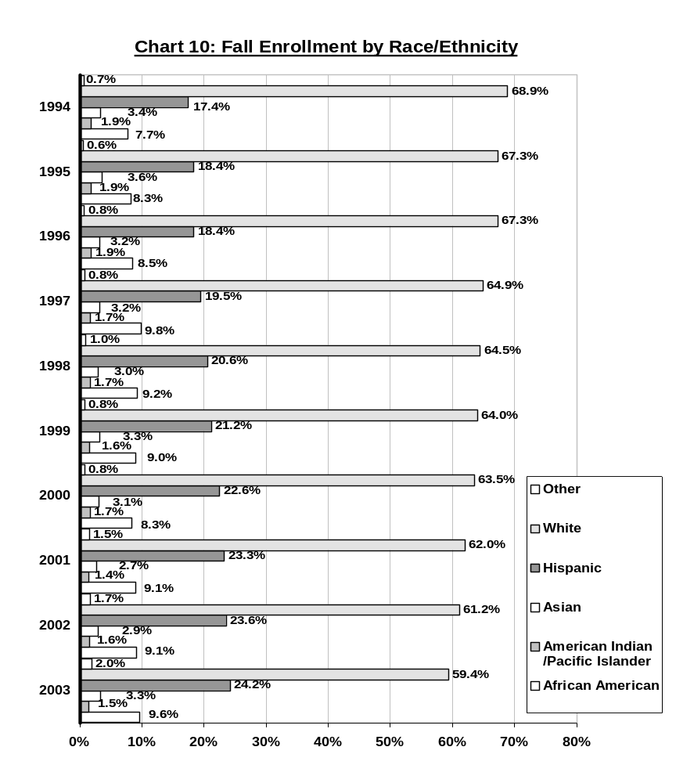
10yearethnicity.xls

Figure 16 depicts that between 1994 and 2003 the Hispanic category viewed a net percent increase of 37.2% while the White category showed a net percent decrease of 13.5%.

Figure 16: Spring Unduplicated Headcount (1st Census) – Race/Ethnicity
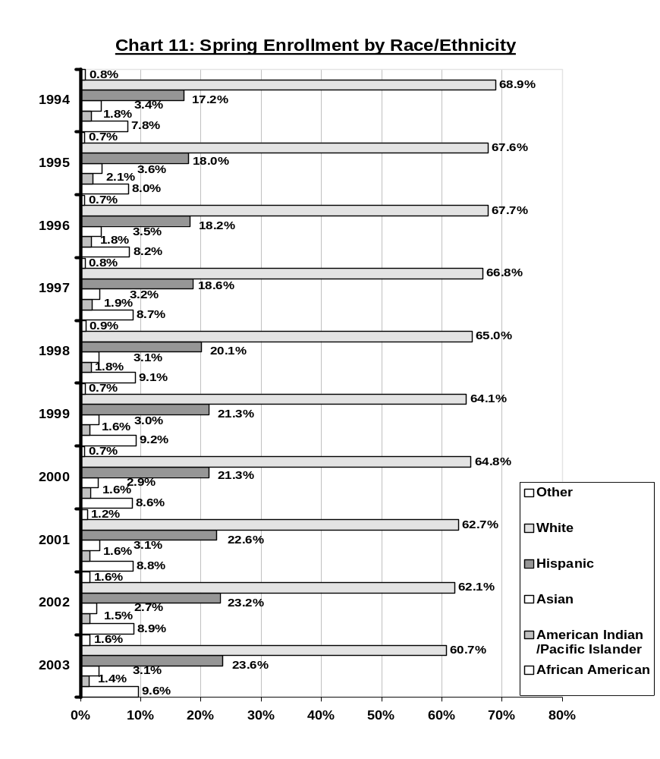
10yearethnicity.xls

Summer intersessions reflect a less dramatic increase in the proportion of Hispanics and a less dramatic decrease in the proportion of Whites. In Figure 17, a net percent increase of 32.3% for Hispanics and a net percent decrease of 3.5% for Whites are viewed.

Figure 17: Summer Unduplicated Headcount (1st Census) – Race/Ethnicity
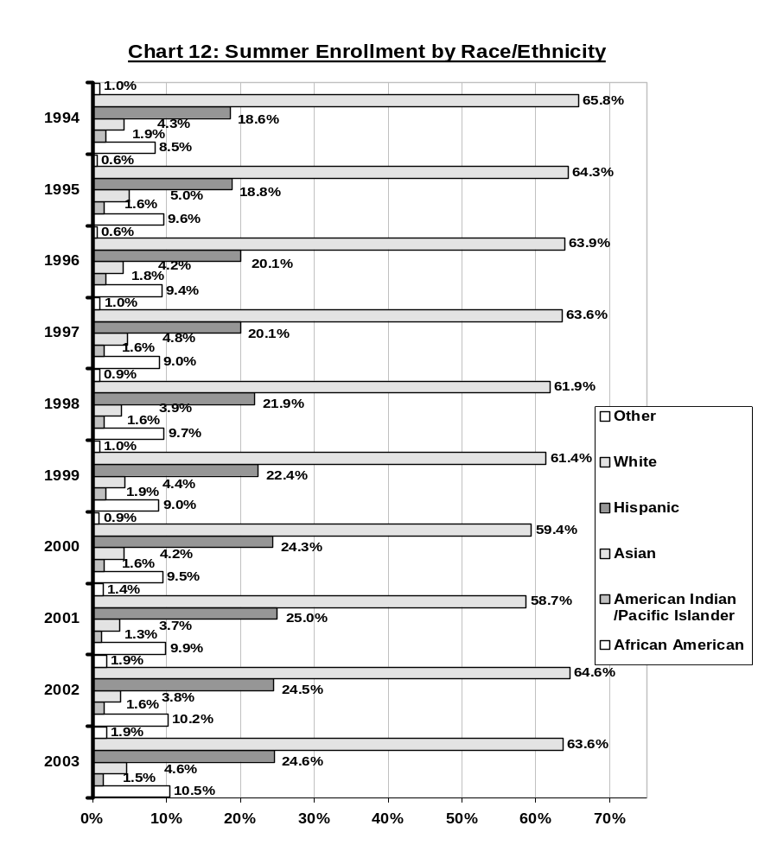
10yearethnicity.xls

Enrollment Projections

In response to Standard 1B (Improving institutional effectiveness) of the new accreditation standards, Victor Valley College is devoted to planning for the future by acknowledging our past.

Figure 18: VVC – Projected Growth for Fall Semesters
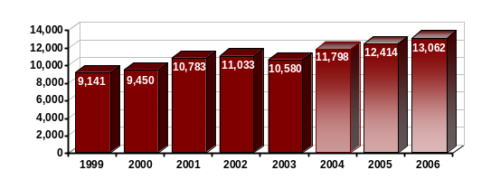
projected_growth.xls

As are other schools of similar size in Southern California (see Figure 19), VVC is experiencing sustained growth. For instance, Figure 18 reveals a projected percent increase from 2003 to 2006 of 23.5%.

Figure 19: VVC – Growth Comparisons
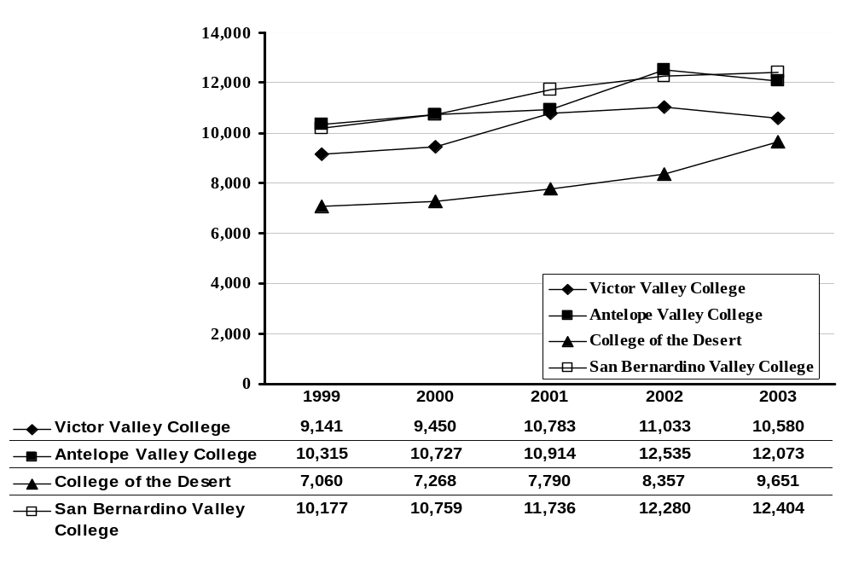
Note: Unduplicated credit headcount at first census projected_growth.xls

Table 6: Attendance by Area (Unduplicated Fall Count at 1st census)
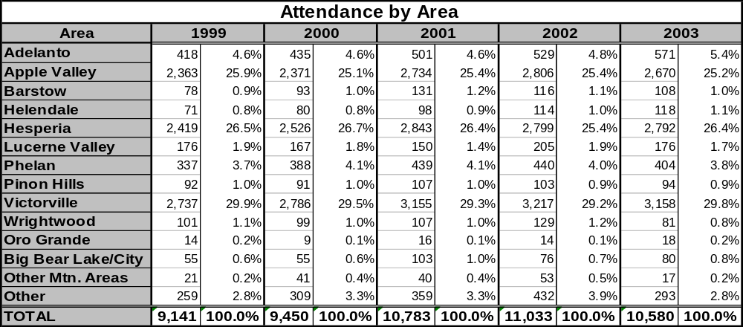
student_origins.xls

Table 6 graphically displays VVC’s growth by surrounding area. 81.5% of credit students in 2003 resided in Apple Valley, Hesperia or Victorville. The largest percent increase in credit students by area from 2002 to 2003 was viewed in Adelanto (7.9%). As depicted in Figure 20, Adelanto is projected to represent the largest percent increase of credit students from 2003 to 2006 (21.0%). In addition, of the “Other areas” categories, the South is projected to have the largest percent increase from 2003 to 2006 (28.7%).

Figure 20: VVC Projected Growth for Fall semester by Region
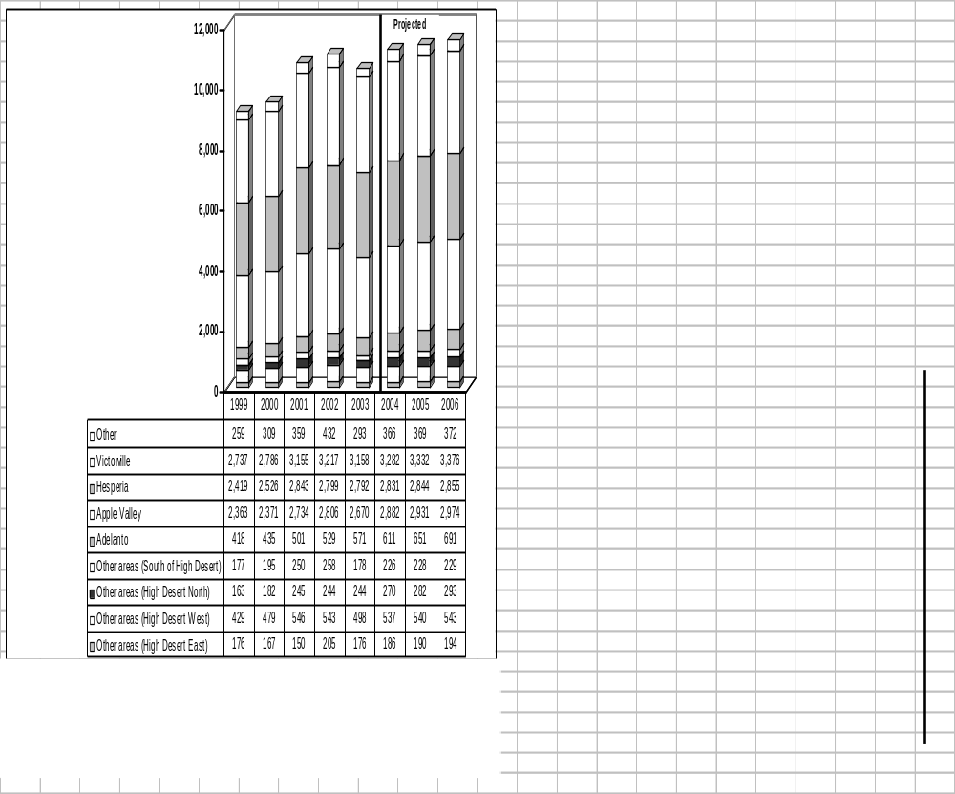
projected_growth.xls

Student Demographics

The “Quick Facts” pages are disseminated on a regular basis to all administrative staff at the end of the term. Along with being presented in the FactBook, documents such as this are also viewable on the IR website.

Table 7: Fall 2003 Quick Facts
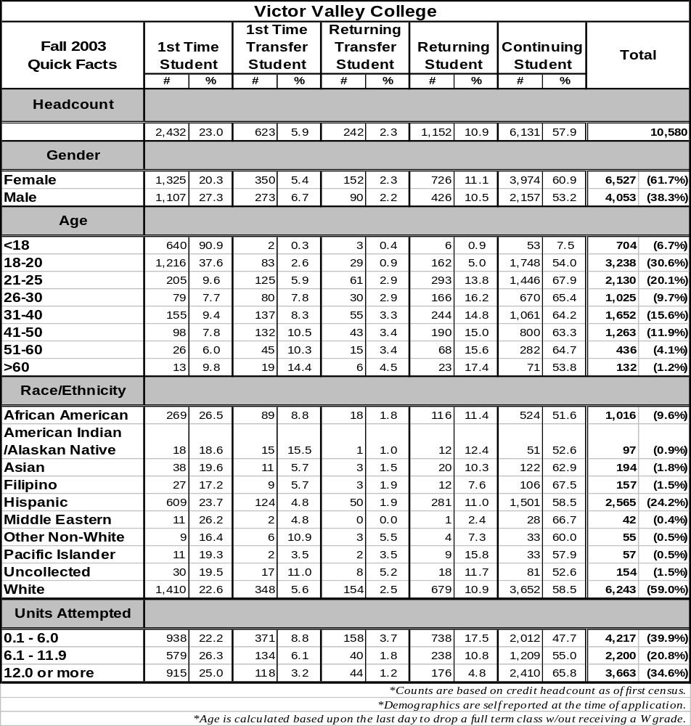 *Counts are based on credit headcount as of first census. Fall03_Quick_Facts.xls
*Demographics are self reported at the time of application.
*Age is calculated based upon the last day to drop a full term class w/out receiving a W grade.

Table 8: Spring 2003 Quick Facts
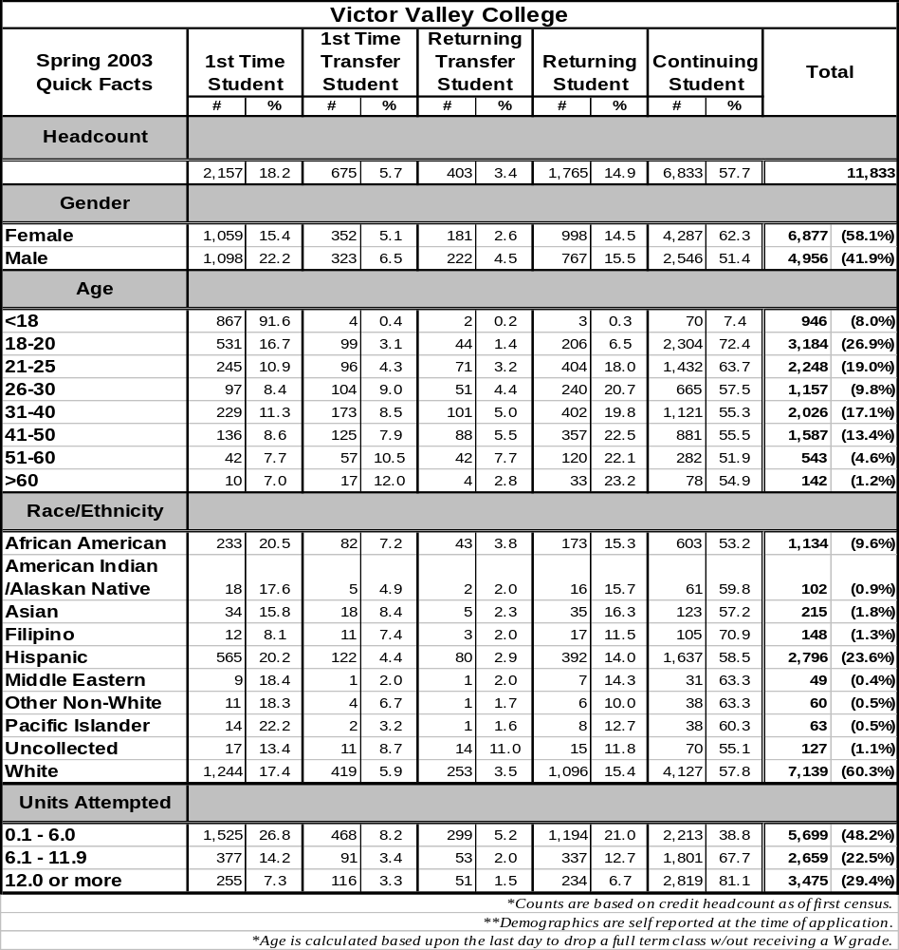
*Counts are based on credit headcount as of first census. Spring03_Quick_Facts.xls
*Demographics are self reported at the time of application.
*Age is calculated based upon the last day to drop a full term class w/out receiving a W grade.

Table 9: Summer 2003 Quick Facts
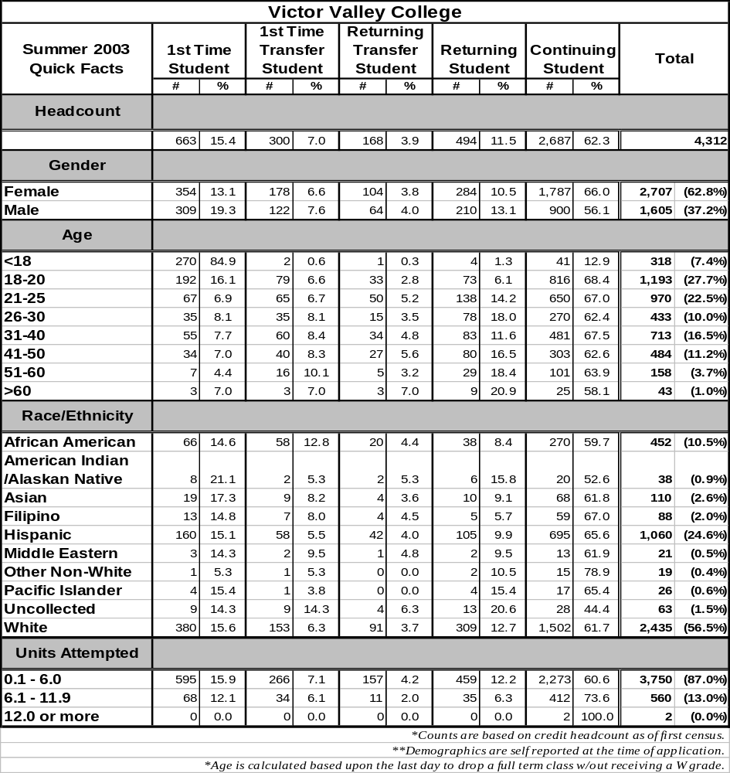
*Counts are based on credit headcount as of first census. Summer03_Quick_Facts.xls
*Demographics are self reported at the time of application.
*Age is calculated based upon the last day to drop a full term class w/out receiving a W grade.

Table 10: Fall Unduplicated Headcount (1st Census) – Major
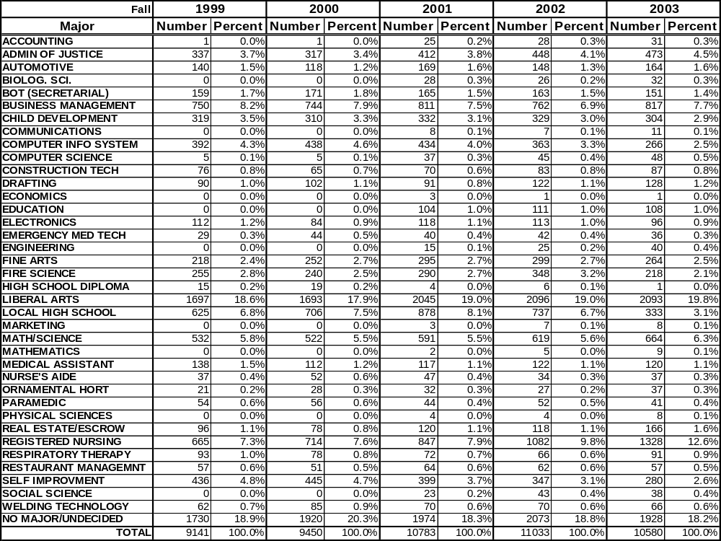
majors.xls
26.1% of credit students in Fall 2003 declared a major of math/science or liberal arts as viewed in Table 10. In the vocational areas, registered nursing (12.6%), business management (7.7%), and administration of justice (4.5%) appear to be favorable majors.
As depicted in Figure 21, on average, less than 4.0% of credit students report their primary language as something aside from English.

Figure 21: Students who reported English as Their Primary Language
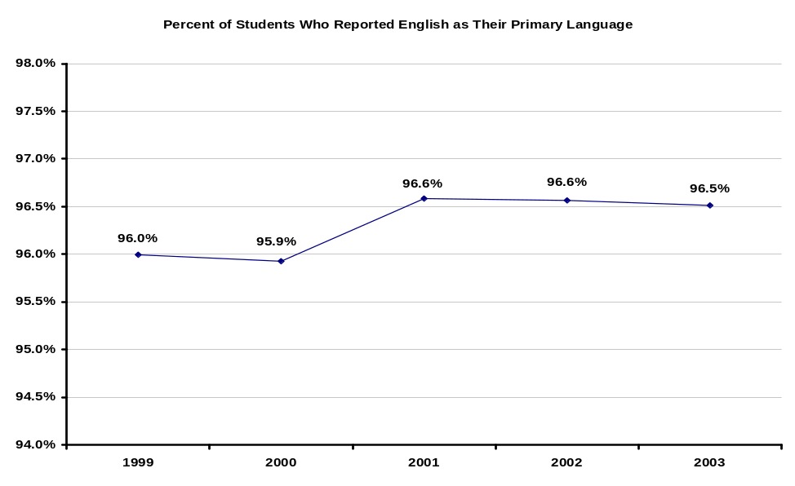
self_reported_data.xls

Table 11: Fall Unduplicated Headcount (1st Census) – Average Work Hour/Week During
Planned Semester of Enrollment
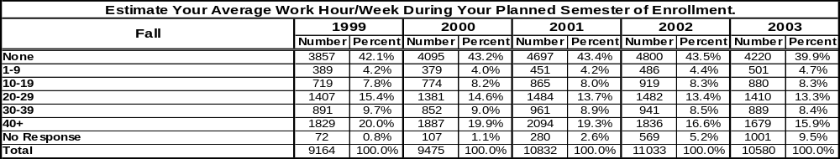
self_reported_data.xls

Table 11 reveals that in Fall 2003 the largest proportion of students (39.9%) enrolled in credit courses did not work. However, the second highest proportion of students (15.9%) is working full-time or more than full-time.

Table 12: Fall Unduplicated Headcount (1st Census) – Educational Status
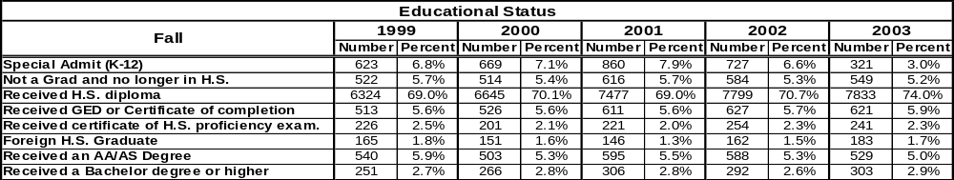
self_reported_data.xls

The highest proportion of credit students enrolled in Fall 2003 reported that they had received a high school diploma (74.0%) as shown in Table 12. In addition, fewer than 3.0% of credit students hold a bachelor’s degree or higher.

Table 13: Fall Unduplicated Headcount (1st Census) – Educational Goal
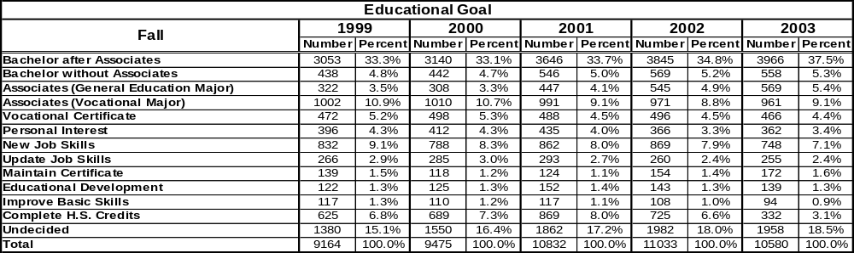
self_reported_data.xls

The number of credit students who report their educational goal as “Bachelor after associates” has increased steadily over the last five years and continues to represent the highest proportion of students (37.5%). Table 13 reveals other educational goals that are well represented such as “Associates (Vocational major)” (9.1%) and “New job skills” (7.1%).

Student Achievement

Table 14: VVC Retention Rate

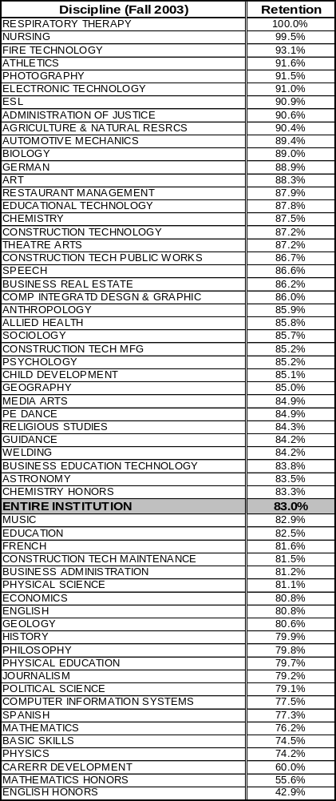 retention_and_success_tables.xls

Retention rate = Percent of students retained in courses out of total enrolled (1st census) in courses. This rate is calculated by dividing the numerator (duplicated student count with grades of A, B, C, D, F, CR, NC, I) by the denominator (duplicated student count with grades of A, B, C, D, F, CR, NC, W, I) and multiplying by 100.

For comparison purposes, the statewide retention rate for Fall 2003 was 82.9%.

Table 15: VVC Success Rate

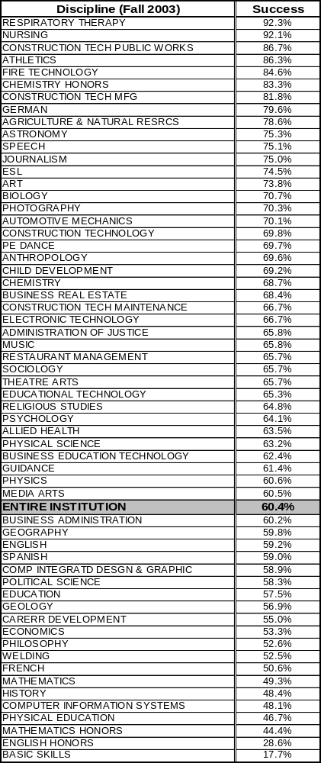 retention_and_success_tables.xls

Success rate = Percent of students successful in courses out of total enrolled (1st census) in courses. This rate is calculated by dividing the numerator (duplicated student count with grades of A, B, C, CR) by the denominator (duplicated student count with grades of A, B, C, D, F, CR, NC) and multiplying by 100.

For comparison purposes, the statewide success rate for Fall 2003 was 67.2%.

As depicted in Figure 22, a percentage point increase of 7.0% is viewed from 1999 to 2003. Success rate during this same time frame has remained very similar with a range between 60.4% and 62.6%.

Figure 22: Overall Retention and Success Rate Trends (1999 – 2003)
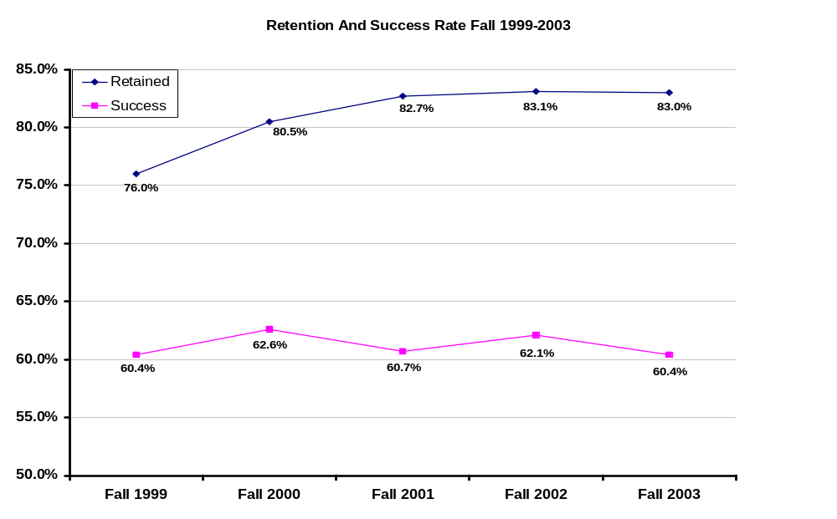
retention_&_succces_rates.xls



Figure 23: Overall Retention Rate by Method of Instruction (2000 – 2003)
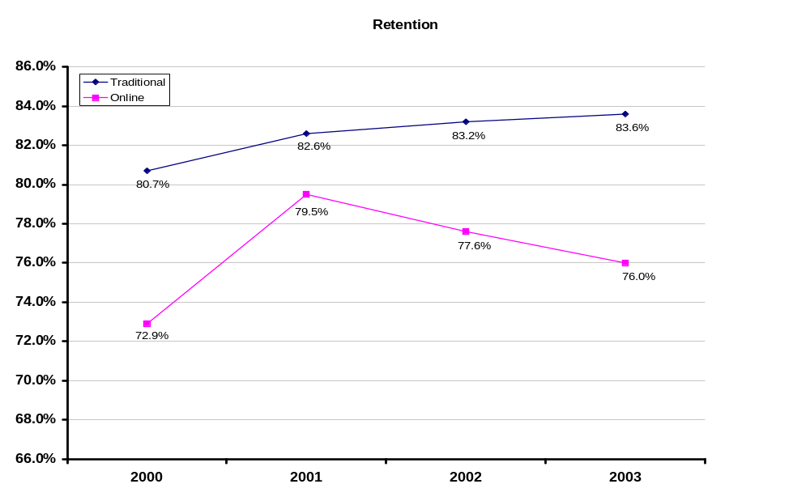
Online_vs_traditional_retentionandsuccess.xls

Over the last four years the retention rate for traditional courses has averaged 82.5% as viewed in Figure 23. At the same time, courses offered online have averaged a 76.5% retention rate. Figure 24 reveals that traditional and online courses have averaged success rates of 62.1% and 52.8%, respectively.

Figure 24: Overall Success Rate by Method of Instruction (2000 – 2003)
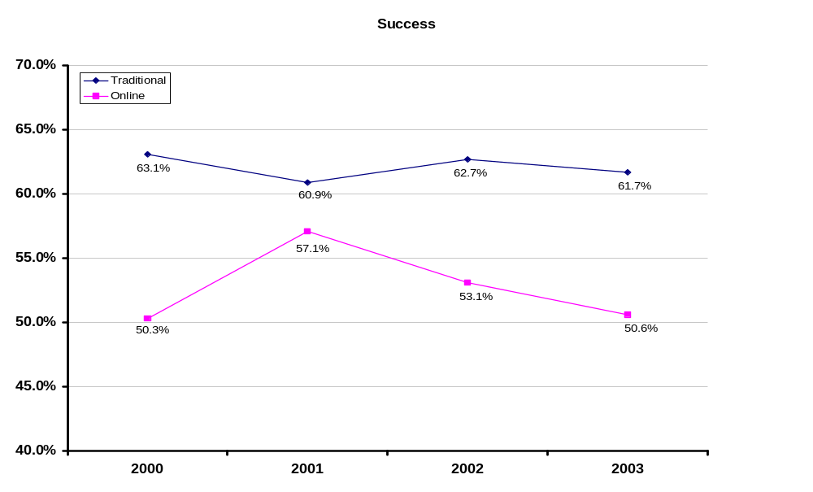
Online_vs_traditional_retentionandsuccess.xls

As part of the Student Equity Plan, indicators such as retention and success in various types of courses were viewed by certain student characteristics. Tables 16 through 23 graphically display these findings for Basic Skills, Vocational Education, Academic, and all courses.

Table 16 & 17: Basic Skills Retention & Success Rate
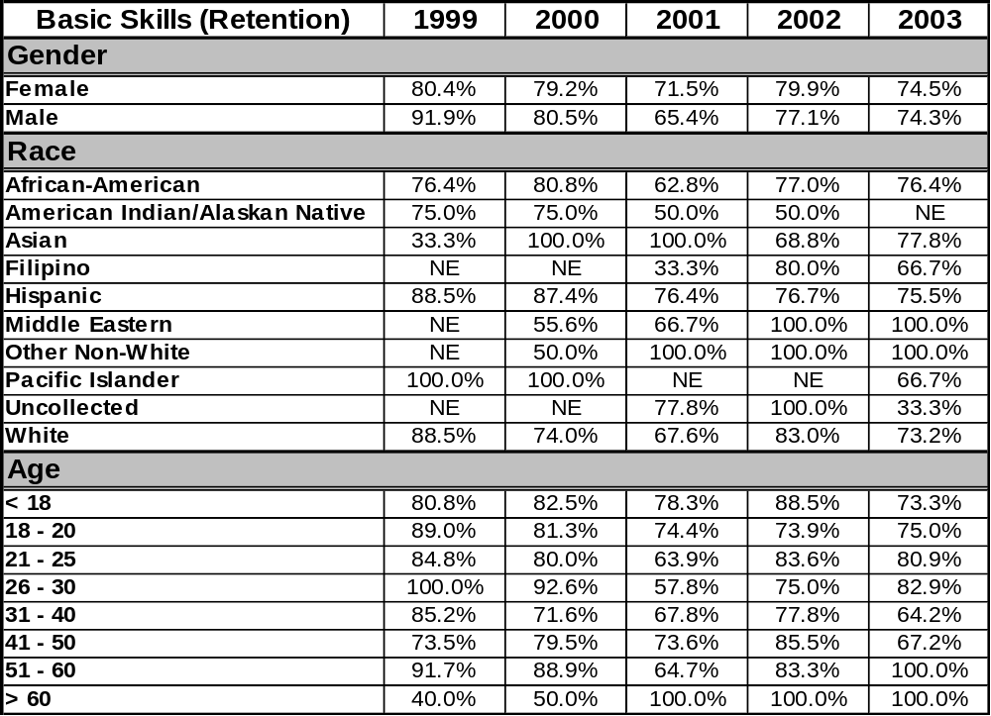
Retention_Breakdowns.xls
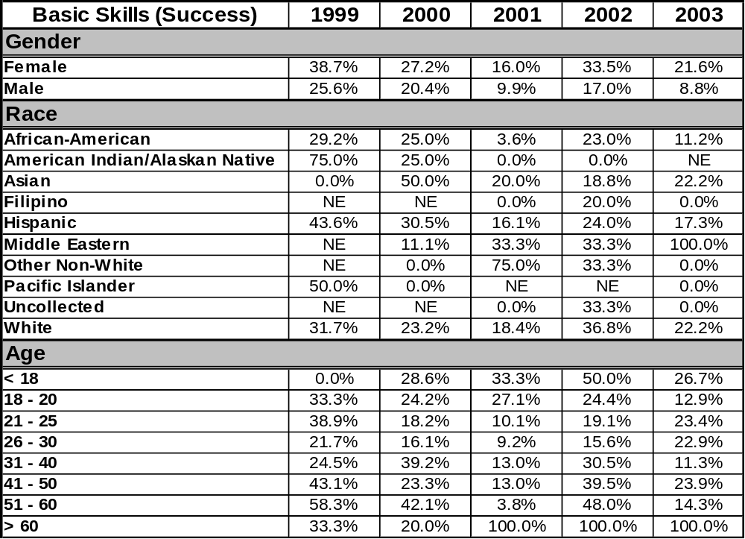
Success_Breakdowns.xls

Table 18 & 19: Vocational Education Retention & Success Rate
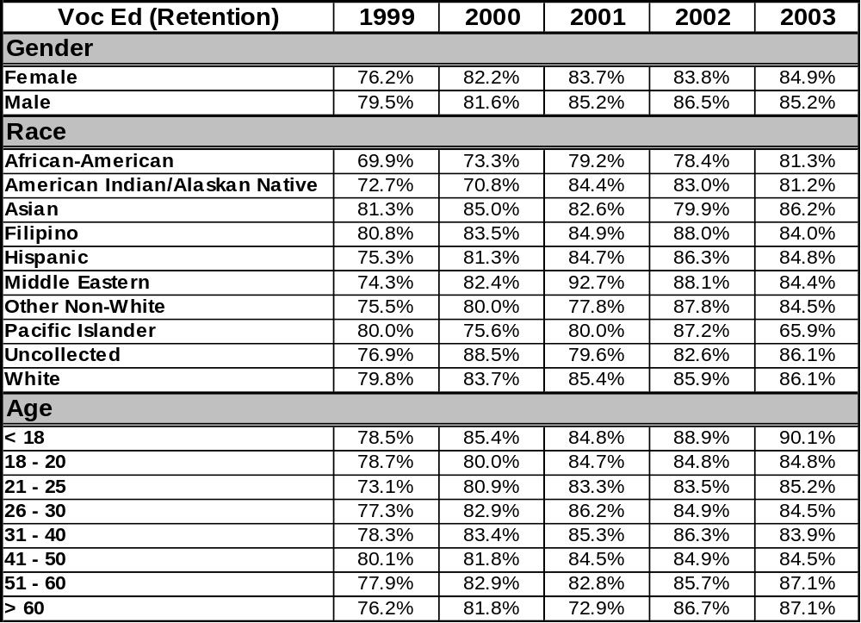
Retention_Breakdowns.xls
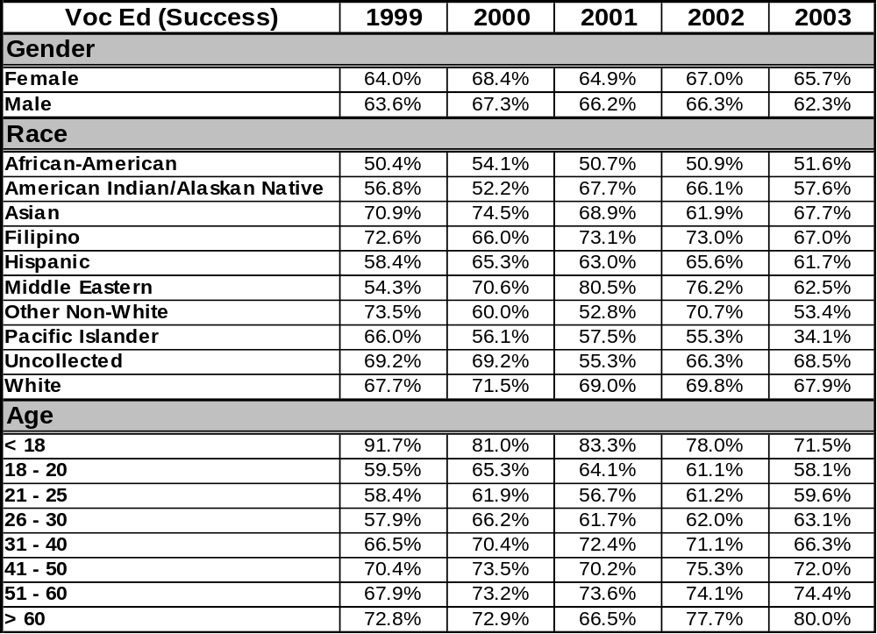
Success_Breakdowns.xls

Table 20 & 21: Academic Courses Retention & Success Rate
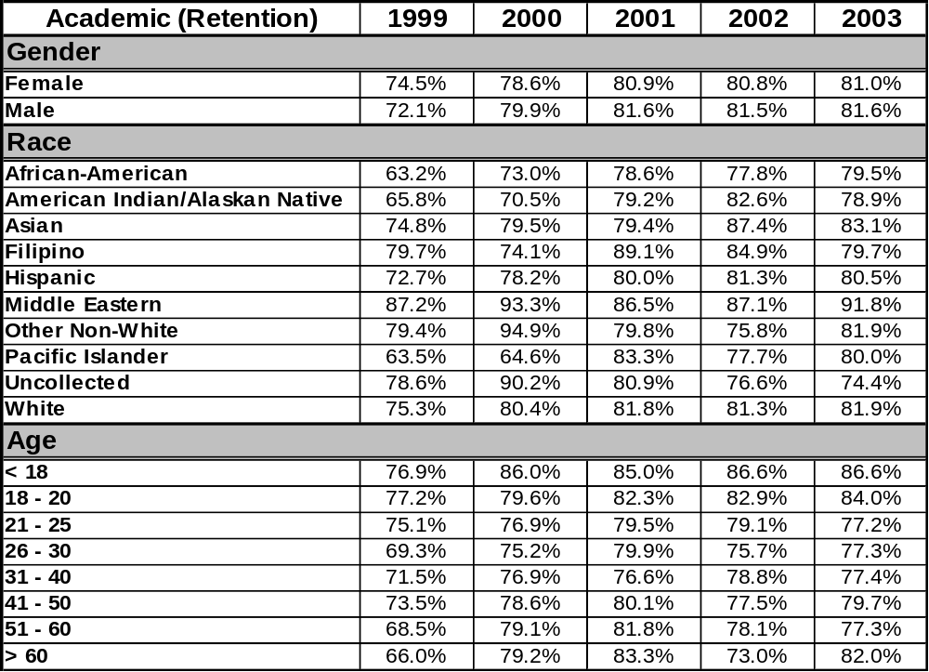
Retention_Breakdowns.xls
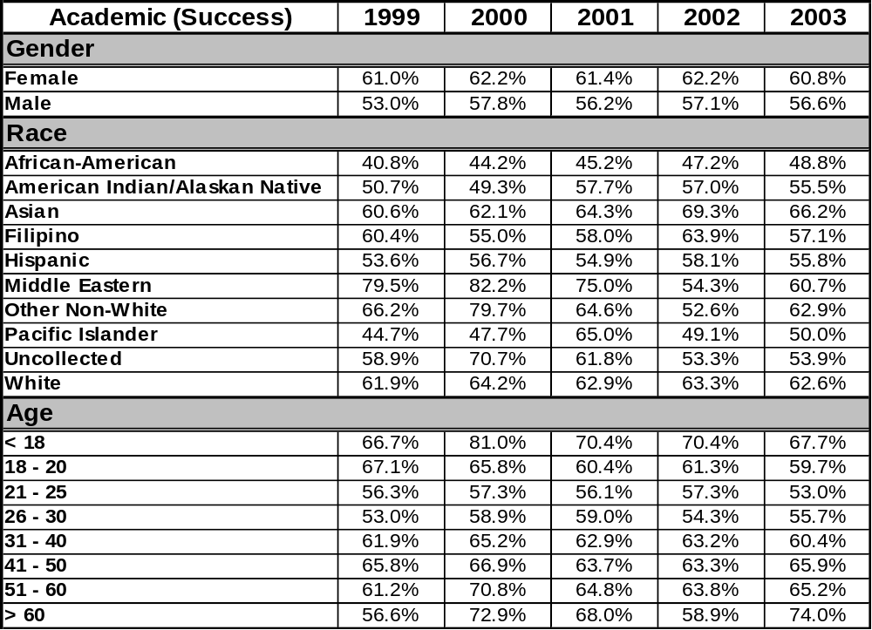
Success_Breakdowns.xls

Table 22 & 23: Overall Course Retention & Success Rate
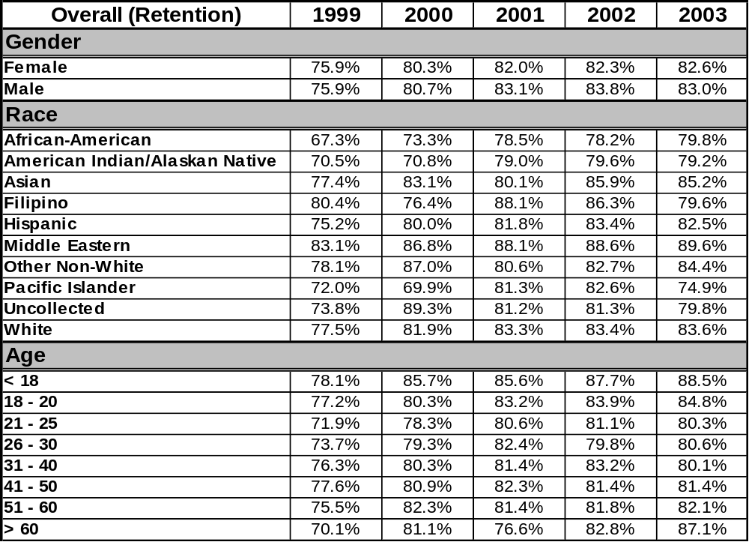
Retention_Breakdowns.xls
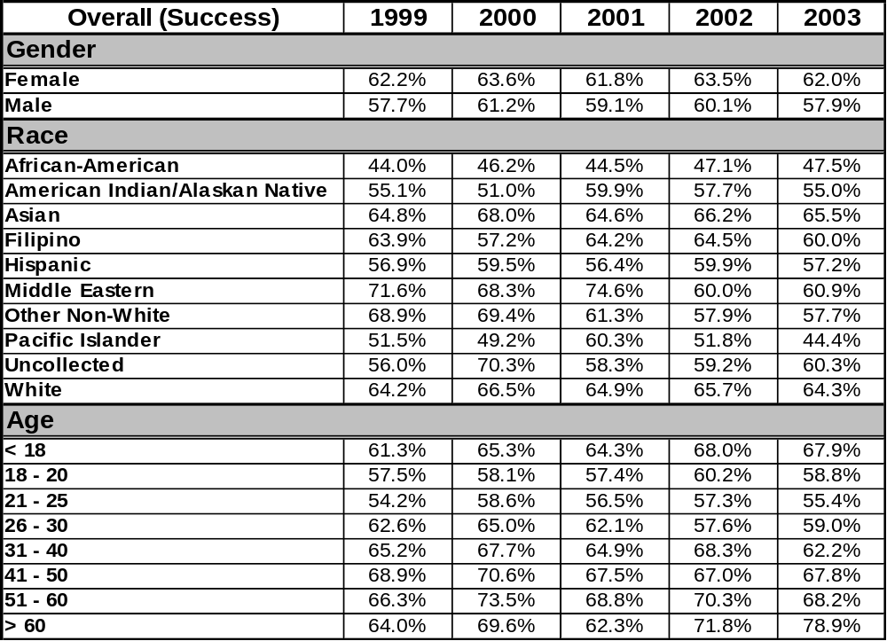
Success_Breakdowns.xls

Figure 25: Average GPA (1999-2003)
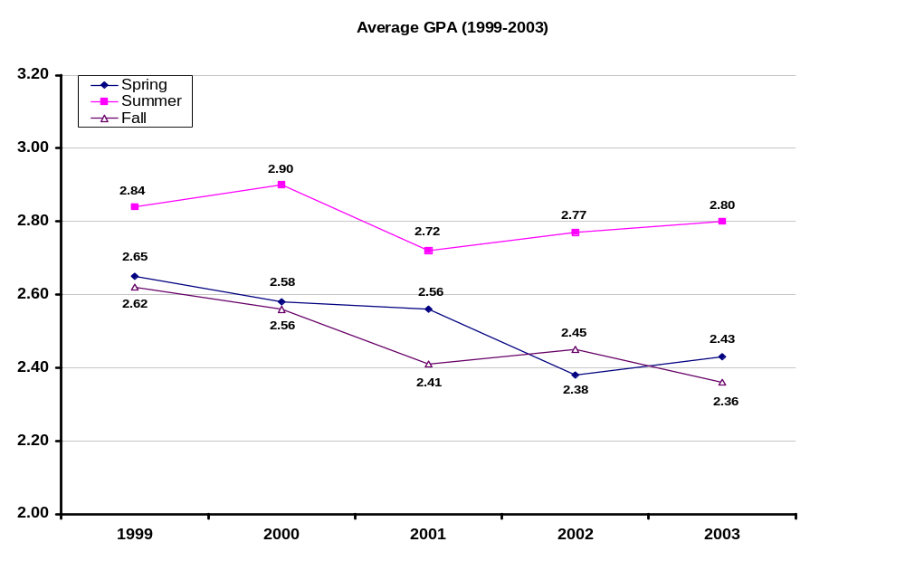
average_gpa.xls
Figure 25 displays the average student GPA by term over the last five years. Summer intersessions reveal the highest GPA with a range between 2.72 and 2.90. Spring GPAs are second highest with a range between 2.38 and 2.65 followed closely by Fall with a range between 2.36 and 2.62.
Persistence rate is based upon a student who received at least one grade in a credit course in the Fall semester and then received at least one grade in a credit course the subsequent Spring semester. As depicted in Figure 26, persistence rates have ranged between 61.6% and 64.9% over the last five years.

Figure 26: Persistence Rate (1998/1999 – 2002/2003)
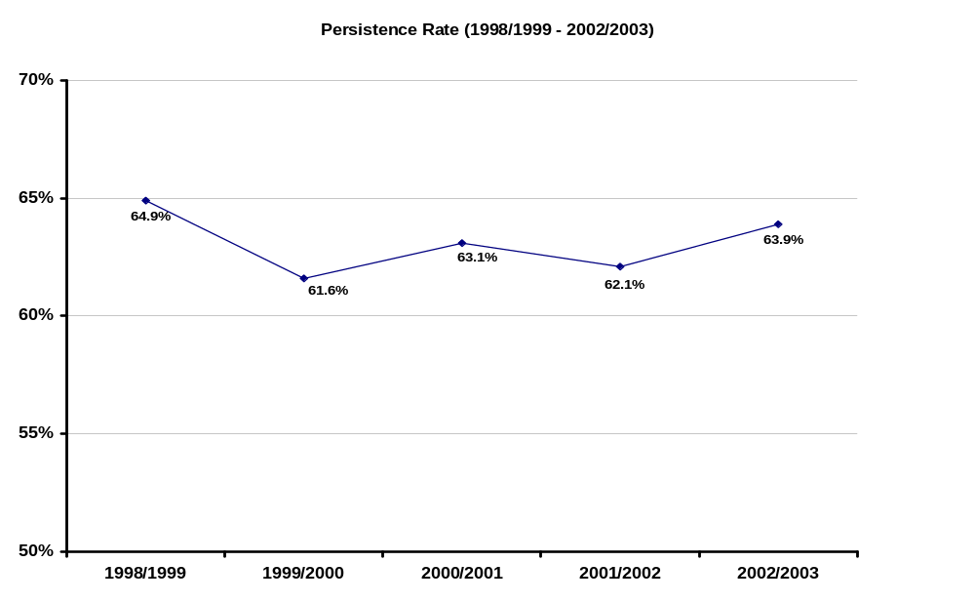
Persistence.xls
One of the prime missions of Victor Valley College is to train or update students that have technical and occupational goals. One set of measures, collected by the Chancellor’s Office (See table 24) and reported out by system and individual colleges, is referred to as “Core Measures” or “VTEA Core Indicator Reports”. While the data are not inclusive, it provides an indication of college program performance and allows for contrasting of accomplishments with other colleges and a performance standard. Interpretation of this data should be made after reviewing the information available at the Chancellor’s Office web site (See source below).

Table 24: VVC Aggregate Core Indicator Information (2004-2005)
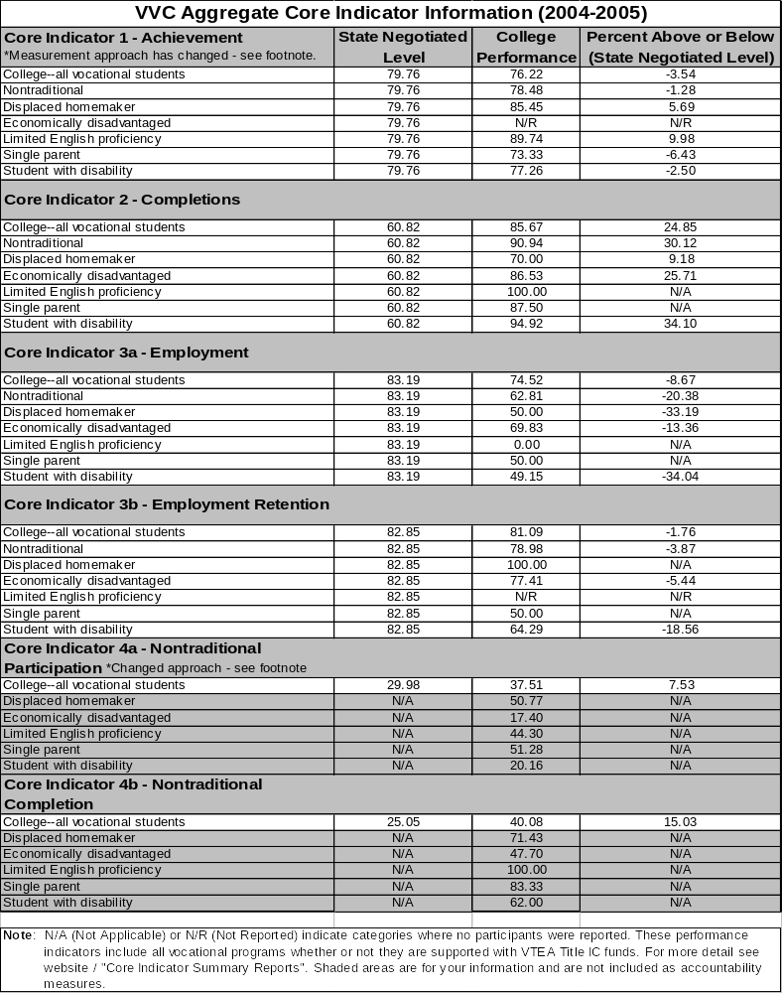
http://misweb.cccco.edu/voc_ed/vtea/vtea.htm Core_indicators_04_05.xls

Figure 27: Degrees and Certificates Awarded by Academic Year (Fall-Summer)
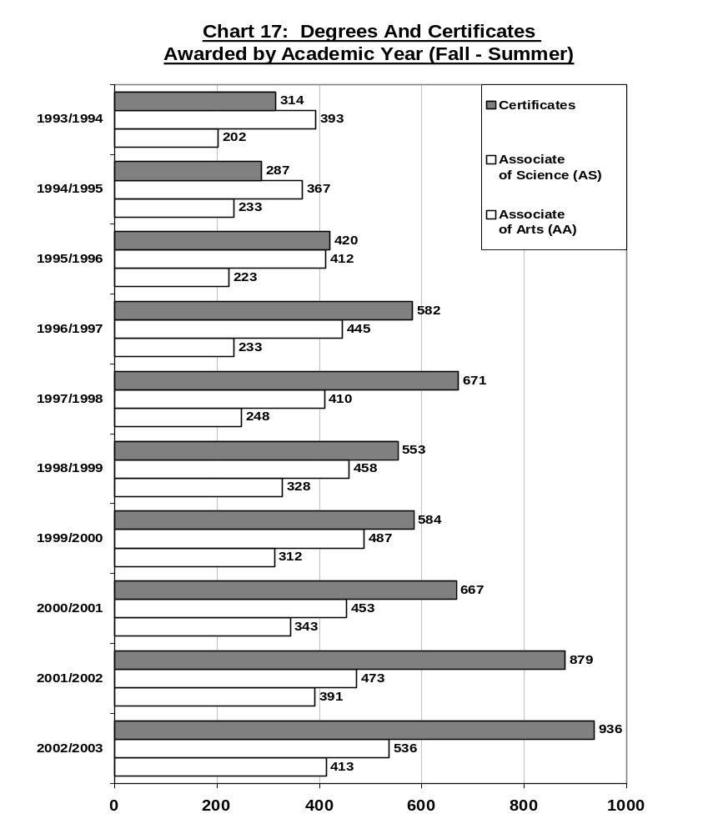
deg_and_cert.xls

Associate of Science and Associate of Arts degrees have steadily increased over the years with 2002/2003 denoting the largest number of degrees in both categories (see Figure 27). In addition, the number of certificates has increased nearly 200% since 1993/1994.

Table 25 reveals that in 2003, Whites were overrepresented in the Associate of Arts (65.3%) and Associate of Science (62.0%) award categories. Hispanics are underrepresented in the Associate of Arts (17.8%) category, yet their proportion nearly matches the population in the Associate of Science category (22.3% vs. 24.2%). In addition, the proportion of African American students who were awarded a certificate is higher then their proportion in the population (13.2% vs. 9.6%).

Table 25: Degree/Certificate by Race
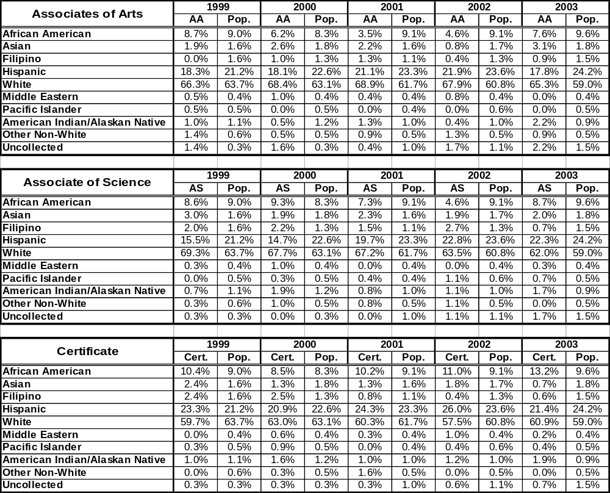
deg_cert_by_race.xls

Females are overrepresented in the Associate of Arts (76.9%) and Associate of Science (71.3%) award categories. However, they are underrepresented for certificates (see Table 26).

Table 26: Degree/Certificate by Gender
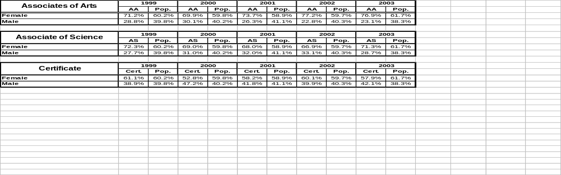
deg_cert_by_gender.xls

As viewed in Figure 28, the number of certificates awarded is projected to increase the most at 18.3% by 2005/2006. The number of Associate of Arts and Associate of Science degrees awarded is also anticipated to increase by 16.7% and 3.4%, respectively.

Figure 28: Projected Change in Awards
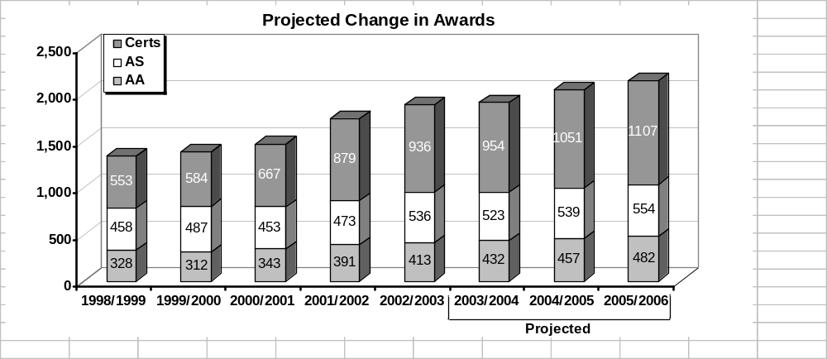
projected_degrees.xls

Transfer-ready students are defined as those who have successfully completed 56 or more units of transferable level courses with a minimum GPA of 2.00 (see Figure 29). Each year’s numbers include students who may have registered at VVC as far back as Fall 1992.

Figure 29: Transfer-Ready Students
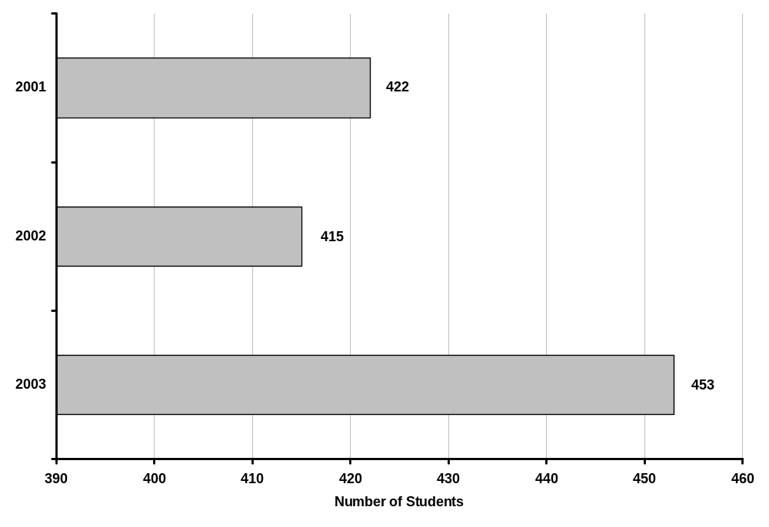
transfer_ready.xls

The following data was obtained by identifying 479 students in Spring 2001 who earned an AA or AS degree. This information was sent to the National Student Clearinghouse and 229 students were identified as transferring to another institution who partakes in the clearinghouse. Table 27 reveals that the highest percentage of students (35.8%) transfer to California State University San Bernardino.

Table 27: VVC Transfers to Public/Private Schools
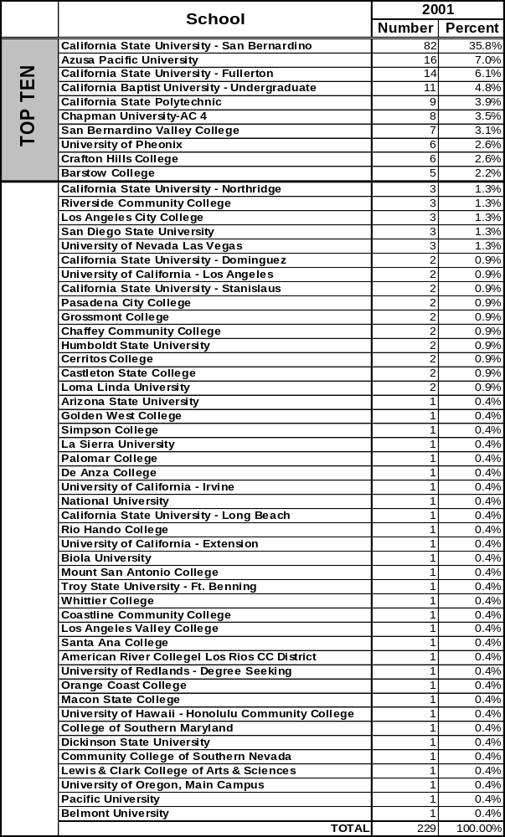
NSCH.xls
The following data was obtained by identifying 485 students in Spring 2002 who earned an AA or AS degree. This information was sent to the National Student Clearinghouse and 218 students were identified as transferring to another institution who partakes in the clearinghouse. Table 28 reveals that the highest percentage of students (44.5%) transfer to California State University San Bernardino.

Table 28: VVC Transfers to Public/Private Schools
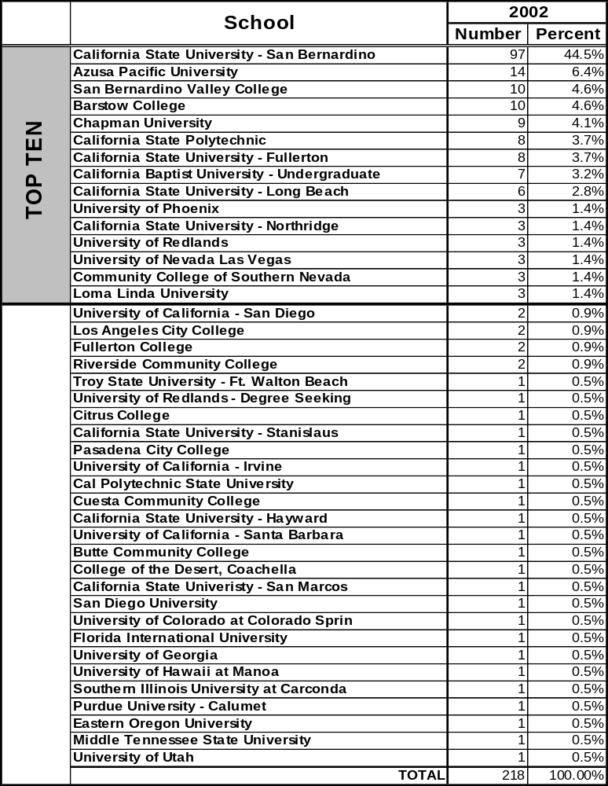
NSCH.xls

The following data was obtained by identifying 502 students in Spring 2003 who earned an AA or AS degree. This information was sent to the National Student Clearinghouse and 150 students were identified as transferring to another institution who partakes in the clearinghouse. Table 29 reveals that the highest percentage of students (39.3%) transfer to California State University San Bernardino.

Table 29: VVC Transfers to Public/Private Schools
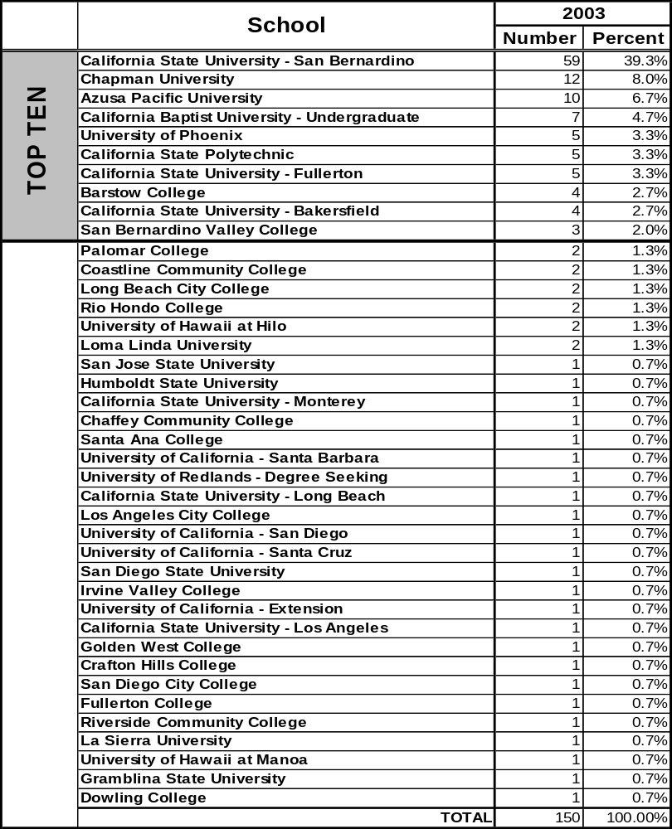
NSCH.xls

As depicted in Table 30, on average over the last five years, 32 students transfer to a UC and 242 students transfer to a CSU. In 2002/2003, the largest percentage of students transferring to a CSU did so at California State University San Bernardino (62.5%).

Table 30:VVC Transfers to UC and CSU Destinations
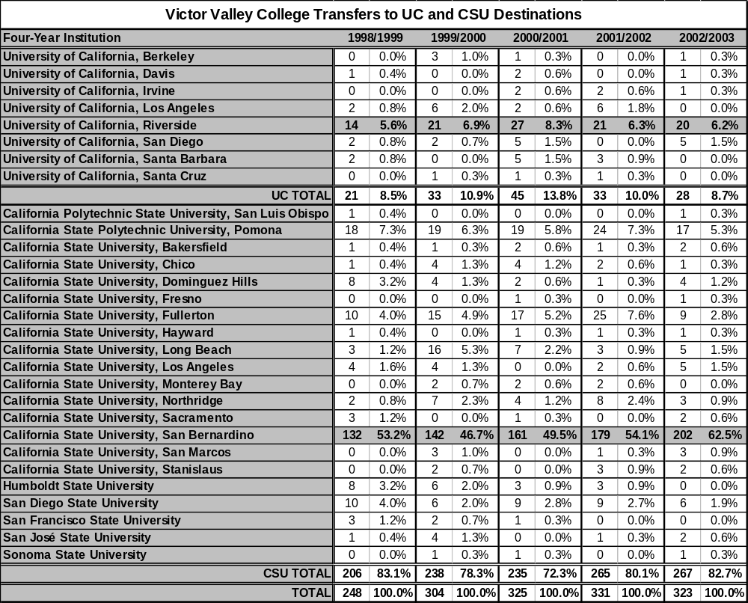
transfers_UC_CSU.xls

The ethnicity breakdown of VVC graduates transferring to a CSU from Fall 1998 to Fall 2002 is shown in Table 31. In 2002, the White population represents the majority (53.3%) of VVC students transferring to a CSU.

Table 31: VVC Transfer Students to CSUs by Race/Ethnicity
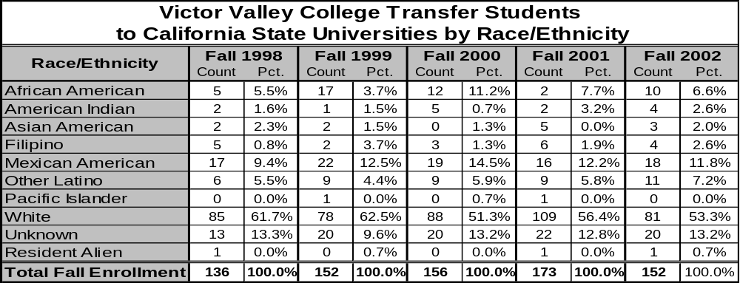
Source: http://www.asd.calstate.edu/scripts/samples/ccct95.idc VVC_transfers.xls

Continuation data are based upon the number of VVC students enrolling in the fall term who re-enrolled in the following fall term (see Table 32). Grade point average was computed only for students who continued from fall to fall. Over the last five years, VVC transfers to CSUs have continued at the same rate as the systemwide average and have earned an average GPA of 3.06. In fact, VVC’s average student GPA was higher than the systemwide average every year except for in 1999.

Table 32:VVC Transfer Students to CSUs by Continuation and G.P.A.
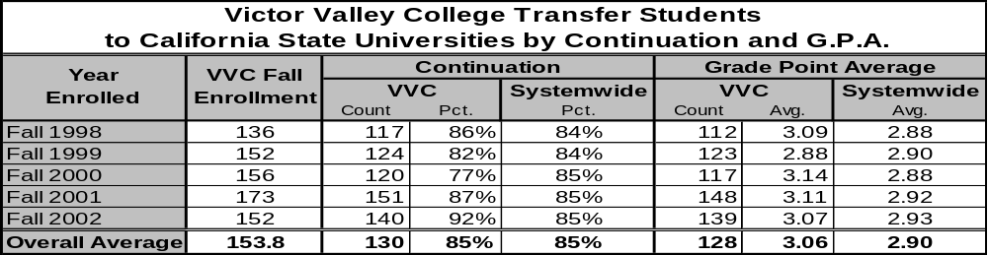
Source: http://www.asd.calstate.edu/scripts/samples/ccct95.idc VVC_transfers.xls

Figure 30 graphically displays the number of nursing graduates and the percentage of those graduates who passed the NCLEX-RN the first time by entrance period. Over the last five entrance periods, on average, 88.4% of graduates pass the NCLEX-RN the first time taking the test.

Figure 30: Nursing Graduates and Pass Rates
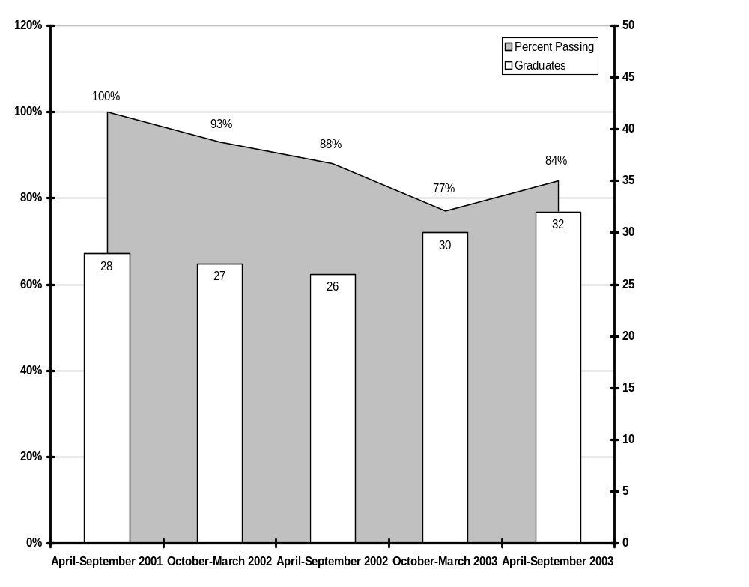
NCLEX_03_grads_percent_passing.xls

Over the last four years, on average, six students obtain licensure in respiratory therapy each year (see Figure 31).

Figure 31: Respiratory Therapy Licensures by Year
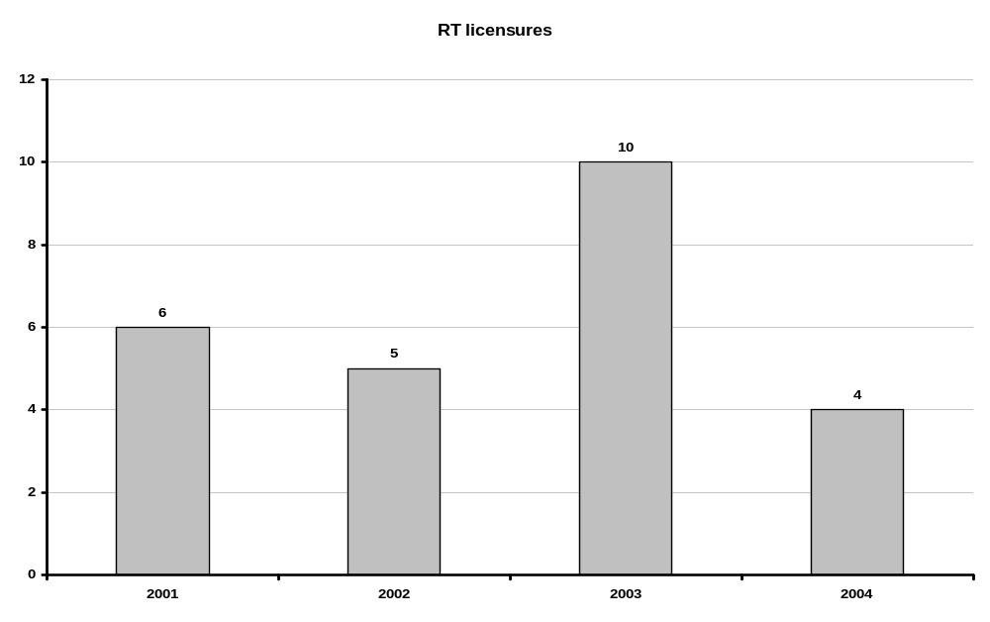
RT_Licensure.xls



Student and Staff Diversity

Figure 32: Student Race/Ethnicity (Fall 2003)
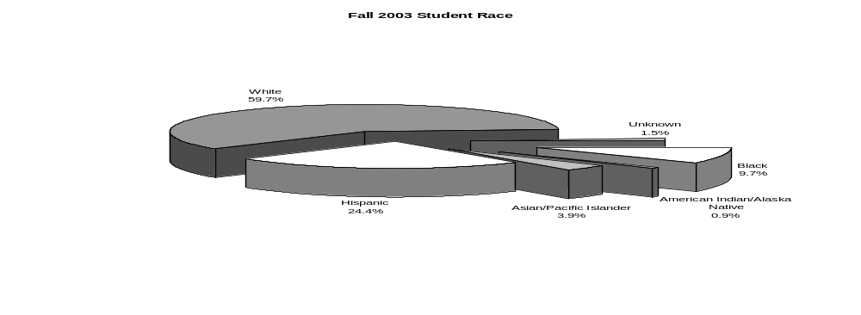
student_and_staff_race.xls

In comparing the race/ethnicity of the staff and students, categories such as Hispanic and Black are underrepresented in the staff; whereas, the White, Asian/Pacific Islander, and American Indian/Alaska Native categories are overrepresented in the staff (see Figures 32 & 33).

Figure 33: Staff Race/Ethnicity (Fall 2003)
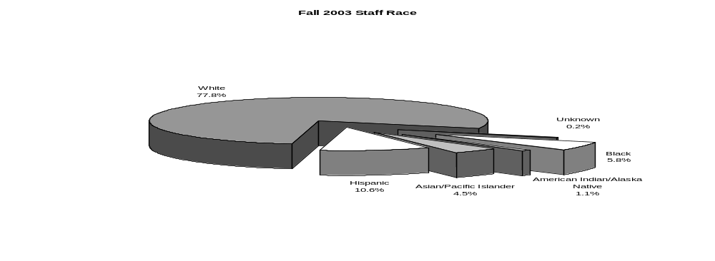
student_and_staff_race.xls

As viewed in Figure 34, nearly two-thirds of students are female, while females represent less than half of the staff.

Figure 34: Student/Staff Gender (Fall 2003)
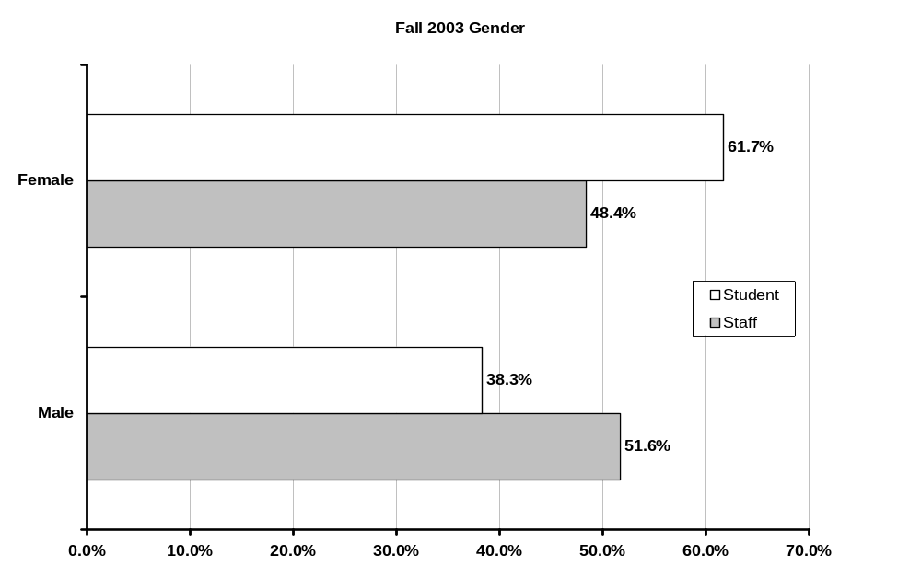
student_and_staff_gender.xls

